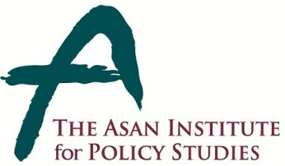 | Press Release
 | January 16, 2014 | For Immediate Release
 | Total of 2 Page | Contact Points:  Ms Heesun Kim  Ms Kahye Oh
 | 02-3701-7387  010-8287-1216  010-4599-8620 | communications@asaninst.org
Rubio To Deliver Remarks On U.S. Policy Toward Asia
- 09:30 on Friday, January 24 in the auditorium at The Asan Institute -

- U.S. Senator Marco Rubio (R-FL) will deliver remarks on US Policy Toward Asia at 9:30 on Friday, January 24 in the auditorium at the Asan Institute for Policy Studies.

- The speech will be followed by a Q&A session.

- Due to limited space, media wishing to attend the following event must RSVP to communications@asaninst.org with details including name, affiliation, and mobile number:

Friday, January 24, 2014
9:30 A.M.
A Conversation with Senator Marco Rubio about U.S. Policy Toward Asia
Auditorium(1Fl.), The Asan Institute for Policy Studies
- Please note: media wishing to film or record the event should contact (Ms) Kahye Oh at communications@asaninst.org (010-4599-8620).

About the Asan Institute for Policy Studies

The Asan Institute for Policy Studies is an independent think tank that provides innovative policy solutions and spearheads public discourse on the core issues in Korea, East Asia and the world. Our goal is to assist policymakers to make better informed and mutually beneficial policy decisions.

The Asan Institute, established in 2008, has successfully hosted a series of international conferences including the Asan Plenum, the Asan China Forum and the Asan Nuclear Forum. It has also published a number of books such as China’s Foreign Policy, Japan In Crisis, and The Arab Spring.

Short Bio of U.S. Senator Marco Rubio

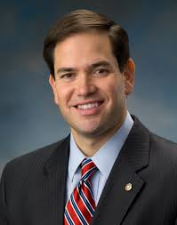
Marco Rubio was born in Miami, Florida to Cuban immigrants and quickly rose to political stardom, making TIME’s 100 Most Influential List.

He entered politics in 2000, serving in the Florida House of Representatives until 2008. In 2010, he was elected to the U.S. Senate. He is a member of the Senate Foreign Relations Committee, where he is the Ranking Member of the Subcommittee on East Asian & Pacific Affairs; Member of the Senate Select Committee on Intelligence; and Co-Administrative Chairman of the Senate National Security Working Group.

He is a graduate of the University of Florida and earned his J.D. from the University of Miami School of Law.

