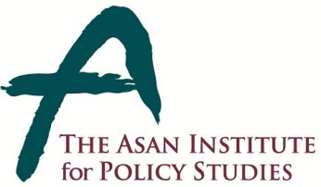 | Press Release
 | February 12, 2014 | For Immediate Release
 | Total of 1 Page | Contact Point:  Ms Heesun Kim
 | 02-3701-7387 | communications@asaninst.org
The Asan Report on South Korean Attitudes on Japan:
Challenges and Opportunities for Korea-Japan Relations in 2014

- On February 12, the Center for Public Opinion and Quantitative Research at the Asan Institute for Policy Studies released its report on Korean attitudes towards Japan and the implication of upcoming events that may further deteriorate the relationship.
- Following Prime Minister Abe’s Yasukuni visit, his favorability rating declined to 1.0 on a ten-point scale. This is the same favorability rating found for Kim Jong-Un. The favorability rating of Japan declined to 2.4 following the visit. This was a 0.2 point decline from early December.
- A near majority (49.5%) of the Korean public remained supportive of a Korea-Japan summit, and a similar number (50.7%) stated support for the signing of GSOMIA. The public also remains supportive of President Park taking a proactive role in improving relations (57.8%).
- The continuing support for improving Korea-Japan relations stems from China’s rising influence in the region. If China continues its rise, a clear majority (63.9%) stated that security cooperation with Japan would be a necessity. A disproportionate number of those who support an improvement between two countries are more wary of the rise of China.
- Dokdo is still cited as the biggest obstacle to improving Korea-Japan relations. This was also true among those respondents with the most favorable attitudes towards Japan, with 49.5% of this group stating as such. The result implies that Koreans will react strongly to any participation by Abe’s government in the upcoming events marking Japan’s Takeshima Day on February 22.
- The data also suggests that perceived U.S. support for Japan could harm Korean perceptions on the United States. Following U.S. support for Japan’s expansion of eventual expansion of its collective self defense, an increased number of Koreans saw the Korea-U.S. relationship as competitive.

About the Asan Institute for Policy Studies

The Asan Institute for Policy Studies is an independent think tank that provides innovative policy solutions and spearheads public discourse on the core issues in Korea, East Asia and the world. Our goal is to assist policymakers to make better informed and mutually beneficial policy decisions.

The Asan Institute, established in 2008, has successfully hosted a series of international conferences including the Asan Plenum, the Asan China Forum and the Asan Nuclear Forum. It has also published a number of books such as China’s Foreign Policy, Japan In Crisis, and The Arab Spring.

