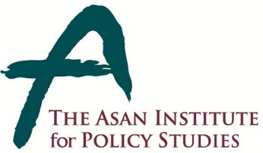 | Press Release
 | May 15, 2014 | For Immediate Release
 | Total of 1 Page | Contact Point:  Ms Heesun Kim
 | 02-3701-7387 | communications@asaninst.org

93 percent S. Korean Find Corruption to be a Serious Problem

- From May 10-12, 2014 the Asan Institute for Policy Studies conducted a public opinion survey on attitudes toward corruption in Korea.
- Corruption in Korean society was cited as a serious problem by 93.4%.
- A plurality (47.5%) stated that corruption was now a more serious problem than it was a decade ago.
- A majority (59.5%) was optimistic that the seriousness of corruption would decline in the coming decade.
- 80.7% cited corruption in the public sector as serious. This was largely consistent across age cohorts and self-identified ideology.
- 76.9% cited corruption in the private sector as serious. This was largely consistent across age cohorts and self-identified ideology.
- A clear plurality (40.8%) cited politics as being the most corrupt.
- A plurality (40.9%) cited stronger punishment as the most important aspect of reducing corruption, while 23.4% stated that those in positions of power needed to lead by example. 22.7% cited the importance of increasing institutional transparency.
- Weak punishment was cited by a plurality (26.1%) as the cause of ongoing corruption.
- A majority (54.4%) opposed parachute appointments, where a public sector officials join the industry they were once charged with regulating.
- The sample size of the survey was 1,000 people over the age of 19. The margin of error was ±3.1% at the 95% confidence level. The survey employed RDD for landline and mobile telephones.
About the Asan Institute for Policy Studies
About the Asan Institute for Policy Studies
The Asan Institute for Policy Studies is an independent think tank that provides innovative policy solutions and spearheads public discourse on the core issues in Korea, East Asia and the world. Our goal is to assist policymakers to make better informed and mutually beneficial policy decisions. The Asan Institute, established in 2008, has successfully hosted a series of international conferences including the Asan Plenum, the Asan China Forum and the Asan Nuclear Forum and published a number of books such as China’s Foreign Policy, Japan in Crisis, The Arab Spring, Escape From Camp 14 and The Orphan Master’s Son. The Asan Insitute for Policy Studies ranked 6th in "Top 45 Think Tanks in China, India, Japan and the Republic of Korea" and was the only domestic think tank that was selected in the "Best Think Tank Conference" by Think Tanks and Civil Societies Program at the University of Pennsylvania.

