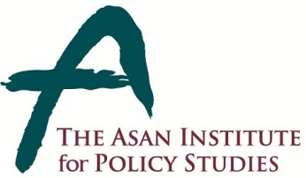 | Press Release
 | May 27, 2014 | For Immediate Release
 | Total of 2 Page | Contact Points:  Ms Heesun Kim  Ms Sungyeon Kim
 | 02-3701-7387  010-8287-1747  010-8867-0767 | communications@asaninst.org

The Asan Institute Hosts Roundtable with
H.E. Salam Fayyad,
- 3 P.M. on Friday, May 30 at the Institute -

- The Asan Institute for Policy Studies will host a Roundtable with H.E. Salam Fayyad, the former Prime Minister of Palestine at 3 P.M. on Friday, May 30 in the conference room (2F) at the Institute.

- Minister Fayyad will deliver a lecture, titled “The Future of Nation-building in Palestine.”

- H.E. Fayyad has been one of the leading proponents of Palestinian statehood and "Fayyadism," the vision of a prosperous Palestine based on sound institutions and rule of law.

* Credentialed members of the press who would like to attend must RSVP to communications@asaninst.org with details including name, affiliation, and mobile number by 12 P.M. on Thursday, May 29, 2014.

About the Asan Institute for Policy Studies
The Asan Institute for Policy Studies is an independent think tank that provides innovative policy solutions and spearheads public discourse on the core issues in Korea, East Asia and the world. Our goal is to assist policymakers to make better informed and mutually beneficial policy decisions. The Asan Institute, established in 2008, has successfully hosted a series of international conferences including the Asan Plenum, the Asan China Forum and the Asan Nuclear Forum and published a number of books such as China’s Foreign Policy, Japan in Crisis, The Arab Spring, Escape From Camp 14 and The Orphan Master’s Son. The Asan Insitute for Policy Studies ranked 6th in "Top 45 Think Tanks in China, India, Japan and the Republic of Korea" and was the only domestic think tank that was selected in the "Best Think Tank Conference" by Think Tanks and Civil Societies Program at the University of Pennsylvania.

Biography of Salam Fayyad

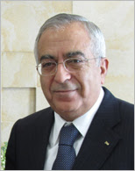
Salam Fayyad is the former Prime Minister and Finance Minister of Palestine. A world-renowned statesman, Minister Fayyad served as the Prime Minister of Palestine from 2007 to 2013. During his tenure, he was instrumental in laying the foundations for a modern Palestinian state based on strong economic growth, political stability and the rule of law in what has come to be known as “Fayyadism.” A renowned moderate, he founded a new political party, the “Third Way” bloc, to contest the 2006 Palestinian legislative elections. A distinguished economist by training, Minister Fayyad also served as Finance Minister from 2002 to 2005, served as the regional manager of the Arab Bank and was the Palestinian representative to the International Monetary Fund from 1996 to 2001. Widely respected in the Arab world and in the West, Minister Fayyad has been one of Time Magazine’s “Time 100 Most Influential People to Shape the World.” He received his B.S. in chemistry from the American University in Beirut, M.B.A. from St. Edward’s University, and his Ph.D. in economics from the University of Texas at Austin.

