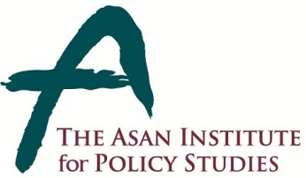 | Press Release
 | July 9, 2014 | For Immediate Release
 | Total of 1 Page | Contact Point:  Ms Heesun Kim
 | 02-3701-7387 | communications@asaninst.org

64.7% positively assess Korea-China summit

- From July 4-6, 2014 the Asan Institute for Policy Studies conducted a public opinion survey on attitudes toward China after the recent Korea-China summit.
- While 64.7% positively assessed the Korea-China summit, just 13.6% negatively assessed it.
- A nearly identical percentage (65.0%) said the summit produced positive outcomes for Korea, with 17.7% disagreeing.
- A clear majority (69.9%) stated that China’s economic rise was a threat to South Korea. This was virtually unchanged from early May when 71.9% stated the same.
- A clear majority (63.6%) also stated that China’s military rise was a threat to South Korea. This was only a slight decline from early May when 66.4% stated the same.
- 59.0% stated that security cooperation with the United States was more important compared to 26.5% that cited security cooperation with China as more important. When this same question was asked in mid-March, 57.1% cited security cooperation with the United States compared to 29.8% that cited China.
- If the US-China relationship becomes more confrontational, 59.6% stated it was more important to strengthen cooperation with the United States. 24.9% cited China.
- In terms on a potential FTA with China, 65.5% were in support with 24.2% opposed. When this question was previously asked in 2013, 48.0% were in support with 27.1% opposed. This was the only significant change among all metrics from pre- to post-summit.
- Regarding the benefits of an FTA, there was a significant increase in the sense that an agreement would benefit both countries equally. In the most recent survey, 48.9% stated as such. In 2013, 41.6% stated both countries would benefit equally.
- The sample size of the survey was 1,000 people over the age of 19. The margin of error was ±3.1% at the 95% confidence level. The survey employed RDD for landline and mobile telephones.

About the Asan Institute for Policy Studies

The Asan Institute for Policy Studies is an independent think tank that provides innovative policy solutions and spearheads public discourse on the core issues in Korea, East Asia and the world. Our goal is to assist policymakers to make better informed and mutually beneficial policy decisions.

The Asan Institute, established in 2008, has successfully hosted a series of international conferences including the Asan Plenum, the Asan China Forum and the Asan Nuclear Forum. It has also published a number of books such as China’s Foreign Policy, Japan In Crisis, and The Arab Spring.

