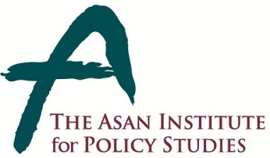 | Press Release
 | Dec. 17, 2014 | For Immediate Release
 | Total of 2 Page | Contact Points:  Ms Heesun Kim
 | 02-3701-7387  010-8287-1747 | communications@asaninst.org
Congressman Honda to Deliver Remarks
on Peace and Prosperity in Northeast Asia
- 10:30 on Friday, Dec. 19 in the auditorium at The Asan Institute -

- U.S. Congressman Mike Honda (D-CA) will deliver remarks on Peace and Prosperity in Northeast Asia at 10:30 on Friday, December 19, 2014 in the auditorium at the Asan Institute for Policy Studies.

- During the event, Rep. Honda will discuss how to achieve peace and prosperity in Northeast Asia covering South Korea’s reunification policy, ROK – US relation and creative economy.

- Due to limited space, media wishing to attend the following event must RSVP to communications@asaninst.org with details including name, affiliation, and mobile number by 4pm Thursday December 18, 2014.

- Please note: media wishing to film or record the event should contact (Ms) Heesun Kim at communications@asaninst.org (010-8287-1747).

About the Asan Institute for Policy Studies

The Asan Institute for Policy Studies is an independent think tank that provides innovative policy solutions and spearheads public discourse on the core issues in Korea, East Asia and the world. Our goal is to assist policymakers to make better informed and mutually beneficial policy decisions.

The Asan Institute, established in 2008, has successfully hosted a series of international conferences including the Asan Plenum, the Asan China Forum and the Asan Nuclear Forum. It has also published a number of books such as China’s Foreign Policy, Japan In Crisis, and The Arab Spring.

Short Bio of Congressman Michael Honda

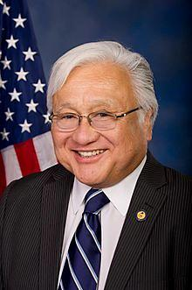

U.S. Congressman Michael Honda represents the 17th Congressional District of California and has served in the U.S. House of Representatives for over twelve years. In Congress, Rep. Honda is a member of the powerful House Appropriations Committee, Chair Emeritus of the Congressional Asian Pacific American Caucus, Co-chair of the Democratic Caucus’ New Media Working Group, and House Democratic Senior Whip.

Rep. Honda’s district includes Silicon Valley, the birthplace of technology innovation and now the country’s leading developer of green technology. He has dedicated his life to public service and is lauded for his work on education, civil rights, national service, immigration, transportation, the environment, and high-tech issues.

Rep. Honda served as a California State Assembly member, Santa Clara County Board Supervisor, San Jose Planning Commissioner, San Jose Unified School Board Member, Peace Corps Volunteer in El Salvador, and with over 30 years in education as a teacher, principal and school board member before the federal congress. He received a B.A. in biology and spanish and his M.A. in education from the San José State University.

