The Future of Work:  The Gig Economy and its Limits | Asan Institute for Policy Studies
 | Peter Ward
 | 2017.02.28

Executive summary

Uber supposedly has taken the world of taxis by storm, offering drivers an endless stream of one-off gigs (drives). Websites like Task Monkey (for errands) and Upwork (for freelancers) are the alleged harbingers of future employment. As computers increasingly replace repetitive labor, more jobs will be done online or with/by super-intelligent machines. Or so hype would have it. But what does this all actually mean for the future of work? In reality, we do not know what the future of work holds, and whether Uber – and other Peer-to-Peer markets – are indeed a permanent part of future employment.

This report takes a critical look at the current state of work in the developed world, and how the so-called ‘gig economy’ is actually part of a much broader, far more complex trend toward the ‘informalization’ of work. While the gig economy and temporary work is a growing part of employment in some countries, this is by no means a universal and irreversible trend. Contrary to conventional wisdom, some parts of the developed world have seen a decline in the number of ‘temporary workers’ and a rise in permanent jobs. The gig economy is also the result of policy decisions and social choice, and not the inevitable result of technological progress or the workings of an ‘invisible hand’.

This report posits three main findings:

(1) Gig work is not intrinsically good or bad. Much of the demand for and growth of gig workers can be attributed to looser, flexible labor markets of specific countries.
(2) Gig workers are not equal. Some are enthusiastic about the flexibility and compensation it affords. Others are forced to work as temps, or agency workers without security or benefits. Many still prefer a ‘permanent deal’ to an endless stream of temporary ‘gigs’.

(3) Government policy matters. The ‘gig economy’ is primarily a creation of government policy, not technology. Uber is actually banned in many parts of the United States, Europe and Taiwan for breach of existing labor laws. We, as a society, ultimately decide how and for what purpose technology is used.

“Without creative accounting it is impossible to survive [as an Uber driver].”
Bobby, an Uber driver in a European city

“They pay better than most care companies, with extra for early mornings, weekends and holidays. I get the hours I like, even if I am on a zero hours contract. It suits me well, particularly for someone of my age. I am lucky to get hours I do, for a company that I believe in.”
Catherine, a care giver and old-fashioned “gig worker”

“I think in a capitalist market, competition is nice and important…. So if the taxi cabs want to compete with Uber and Lyft, why don’t they provide some of the same services, or why aren’t they nicer?”
Deborah Jeff, a retired nurse

The gig economy of ‘freedom’ and convenience
So you missed the last bus, miles from home with no car. How are you going to get home? In many places the answer is simple: call an Uber. Thinking about going on a trip and want to save money? How about Couch Surfing or Airbnb? And if need to get a handle on your overgrown garden, or clear out a loft, then TaskRabbit can get someone to your door in minutes. If your business needs a new website, Upwork has many potential designers eager to work. Having legal issues? Then Upcounsel can help you find a lawyer on-demand.

This is the wave of the future crashing on the rocks of the present. Part and parcel of a techno-utopia, this touts freer markets in cyberspace with freer gig workers. This freedom is to be enjoyed by workers who want flexible gig work and employers who want to reduce costs. But some countries have proven to be less accepting of this cyber-based, free market utopianism. And for good reason: the gig economy means the proliferation of temporary jobs. But it also means poorly compensated jobs, offering fewer benefits with little job security.

But the gig and its older brother, the temporary worker, predate cyberspace and Uber by decades. Nonetheless, the growing informalization of work has profound implications for the future of employment and the economy. In the United States, where many welfare benefits are provided by the employer, gig work and temping can mean no health insurance, no social security contributions, no retirement fund, and no regular salary. It also means no fixed income, which can make it far more difficult to get a mortgage or other kinds of personal financing. Permanent, regular employment would mean that the employer would offer a certain number of hours of work per week for a set wage. The compensation package would include paid vacation and sick days, health and dental insurance, and pension contributions. However, with gig work, no such regularity and wage exists.

That said, not all gig jobs are alike. Many gig workers moonlight after normal working hours as a part-time Uber driver for extra money. Many designers, programmers, photographers, translators, event planners, and other workers, especially in the creative industries, also work from contract to contract, and increasingly make use of online platforms like Upwork to connect with potential clients. Some of these gig workers may be handsomely compensated and often prefer the freedom from the traditional nine-to-five office.

Indeed, different kinds of gigs pay very different rates. Owning a penthouse in the center of London and leasing it for six months on Airbnb is certainly far more lucrative than being an Uber driver in that same city. Translating freelance for Bank of America in Taiwan or designing a new logo, freelance, for a French pharmaceutical company are jobs far better paid than, say, being a part-time photographer in a small town in southern Spain.

However, the fact that temporary/gig work is more prevalent in some countries should not be forgotten. This difference is attributable to state regulation, social norms, and values. Silicon Valley’s techno-utopianism may make you think that the gig economy is inevitable, but how an economy is structured has as much to do with how society and the state decide to use technology. Indeed, some places like Anchorage and Palm Beach in the United States, Hong Kong, parts of Australia, France, Germany, the Netherlands, the UK, and Romania have either banned Uber outright, or restricted some of its services.

Therefore it is not technology per se, but societies and states that decide how the economy should work and distribute the consequent economic benefits. Technologies can be exploited to fuel social inequalities, rendering work less permanent and making the livelihood of workers more tenuous. But those very same technologies can also be in the service of improving the wages and welfare of workers. Society can choose to champion the importance of entrepreneurship, risk, and independence, leading to a smaller state and lower taxes. But as the famous economist of entrepreneurship William Baumol observed, entrepreneurs innovate but their innovations are not necessarily good for society as a whole. In the final analysis, how technology is used and the kinds of employment relations it creates are social not technical choices.
The Gig Economy and the world of work

What is the gig economy?

The gig economy is a term commonly associated with work done on-demand, via a smartphone app or the internet. Uber, Lyft, Airbnb, and TaskRabbit are just some of the most well-known brands of a booming industry in peer-to-peer (P2P) markets, in which sellers provide services (and sometimes goods) for prospective buyers.

The phrase is also used as a catch-all for many different kinds of temporary work provided on-demand, either through an agency or on contract by workers in informal employment. Working under such arrangements means that workers have many or all of the responsibilities of a permanent employee without many of the benefits. This lowers costs for firms and is reflected in the price consumers pay for goods and services. Further, the flexibility of such work arrangements is favoured by some workers who would prefer to work part-time or on a fixed contract. However, many workers still prefer a permanent job with stability and benefits.

How big is it?

In October 2016, the McKinsey Global Institute released a report on the gig economy. From a survey of 8,000 Europeans and Americans, they found that some 20-30% of the working age population engaged in “independent work.” But as the chart below indicates, the size of online platforms as a share of the totality of all independent work is still quite small (15%).
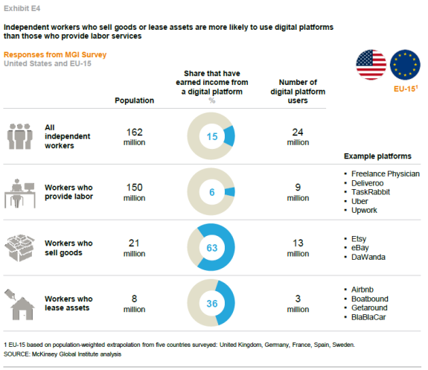
Source: McKinsey Global Institute

Indeed, a recent NBER study by Harvard economist Lawrence F. Katz and Princeton economist Alan B. Krueger indicates that workers on online platforms only constitute 0.5% of the American work force. Suffice it to say, this is miniscule in the grand scheme of things.

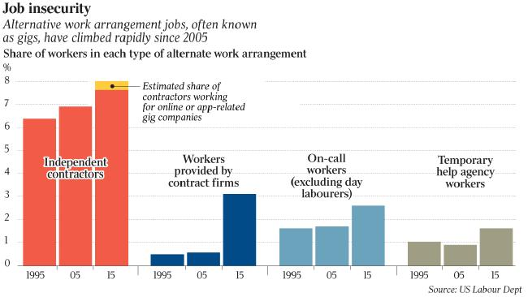
Source: The Wall Street Journal

Measuring informal work, including gig work, is no easy task. Workforce survey methods are designed to capture full-time workers. Part-timers, contractors (and independent workers), and the self-employed are lumped together with full-time workers, yielding imperfect measurements. That said, the Katz-Krueger figures cited in the chart above indicate that informal work constitutes about 15% of all US employment as of 2015.

Temporary employment is a large growing part of the workforce in some countries of continental Europe, including Cyprus, Poland, the Netherlands, Italy, and Iceland. But in other parts of Europe, such as Germany, the UK, Spain, France, and Sweden, the trends lean towards less temporary work or more limited growth. See the table below for more information.
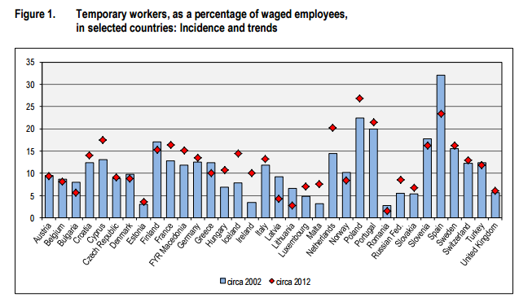
Source: International Labour Office, "Non-standard Forms of Employment", Report for discussion at the Meeting of Experts on Non-Standard Forms of Employment (Geneva, 16-19 February 2015), p. 5.

This underscores the fact that temporary gig work is not expanding uniformly across the developed world. In some places, governments have taken a more tolerant approach to temporary work. In other places, where people assume that if you perform a service for a company you essentially become its employee, the approach toward temporary work is much stricter.

The hype that surrounds services like Uber and Airbnb often makes it appear as if the gig economy is an inevitable and irreversible development. However, as the above statistics indicate, the prevalence and trends in temporary employment differ dramatically across the developed world. What’s more, “temporary work” is a broad category that has different meanings in different countries. Although there has been some convergence toward the neoliberal model of flexible labor markets across the developed world, there is still a huge difference in the level of protection that workers enjoy in much of Western Europe vis-à-vis the United States. Thus, a temp in Belgium potentially has more rights (like the right to a written work contract) than his counterpart in the US.

The gig worker

The status of gig workers in different parts of the economy is contested, as the case of Uber demonstrates: a British tribunal, for instance recently ruled that Uber must give minimum wage and holiday benefits to its driver’s.. Indeed, Uber is actually banned in many parts of the United States and elsewhere for such labour law violations, or due to other policy concerns.

That said, workers in the gig economy benefit from flexible hours and freedom from the traditional nine-to-five job. The same McKinsey Global Institute study cited above found that 70% of those surveyed chose to engage in independent work because they wanted to (see table below). Note, however, in all the countries included in the survey, permanent employment is the principal employment relationship. Hence, gig work remains a source of supplemental income for the majority surveyed. And 30% of gig workers are unwilling participants in this growing sector of the economy. They participate because they have to in order to survive, not out of choice.
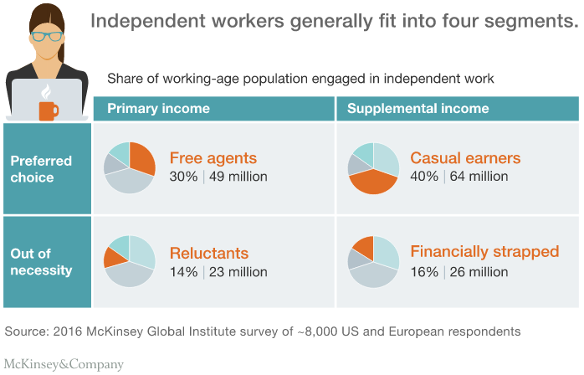

Some gig workers are seemingly freelancers, like those who find work through sites like Upwork. In reality, however, the relationship that exists between the supposed freelancer and the client purchasing their services is more complex due to the presence of an intermediary – i.e. a website/app. These P2P markets have led to the construction of new kinds of employment relations. They operate on the premise that, as intermediaries, they do not employ the workers on their platforms. This begs the question - are workers on these platforms independent contractors, as Uber maintains? Or are they something else, like dependent contractors, or employees?

Gig platforms

As the intermediary, the P2P market is directly involved in the jobs that workers perform via the platform. Hence, it has some liability for them, their conduct, their security, and welfare. The crux of the controversy surrounding P2P markets for employment comes down to flexibility versus security.

Most workers who use such platforms have a certain measure of freedom to decide when they work, but once they begin, they are reliant on the brand of the app/website from which they get their customers – who often sets the price the worker gets paid. The reason why someone uses an Uber driver is because it is a cheap and trustworthy service. This credibility is what gives Uber and other similar platforms their brand power. This also gives them market power. Uber is a well-recognized brand with global reach, whereas its individual drivers are basically unknown service providers. The situation is similar with Upwork, a P2P market for “freelancers.” It is widely used because it lowers the cost of connecting buyers with sellers (via the internet) while also guaranteeing quality control by providing a centralized source of information on product quality, i.e. feedback profiles for both buyers and sellers. Here is the difference from a classical freelancer: the gig worker is tied to Upwork whenever they work for the client they initially found via the service.

These are clearly less salient issues in countries where it is assumed that unless you are the employer/owner, you are an employee. Uber would struggle to operate the same business model in such countries. Similarly, Upwork’s business model and non-circumvention agreements with freelancers that use the platform could contravene labor laws in many OECD countries. It is also less of an issue in countries where the state is the primary provider of pensions, healthcare, and other employment-related benefits. But countries with better social welfare usually have stronger unions and stronger social democratic traditions (Sweden, France etc.) and thus can afford to have less tightly regulated labour markets (but often still do not). Less well regulated labour markets result in employment that is more informalized because such flexible arrangements are often beneficial for employers. Yet these arrangements can result in lower wages and more insecurity for workers. We should not forget, however, that not all workers want permanent, nine-to-five jobs. Some only need or want gigs to get by, or have highly marketable skills with which they earn a higher income by providing services to the highest bidder.

The platforms gig workers usecontribute to a greater informalization of work the taxi and hotel industries. But the business model itself for Uber and other P2P markets may not always be viable. As the example of Homejoy demonstrates, many P2P markets simply may not work because people would prefer to deal directly with a trusted supplier or have a permanent member of staff to provide services. Stories about the amounts of money that Uber continues to hemorrhage, in spite of their record-breaking valuation, indicate that their hopes of corning the market remain distant.

Looking ahead

The rise of the gig economy is closely linked to technological change. First, technology has created new jobs and rendered other jobs obsolete. In the 19th century, factory machines and mass production put many craftsmen out of business, and ‘deskilled’ the production process. The fear/hope is that machine learning, AI and advanced robotics will render many technical jobs unnecessary. Second, technology has made it easier for employers to hire temporary/gig workers. Platforms like Upwork and Uber allow companies and other entities/individuals to quickly find certain kinds of workers with the right skills. But P2P markets only account for a small slice of informalized, temporary work in the United States, a nation with arguably the most liberal labor markets. While the rise of the gig worker is bad news for many unskilled workers (or workers in “deskilled” jobs), it is potentially good news for skilled workers interested in flexibility and higher (if more irregular) pay.

Deskilling and the death of the nine-to-five job?

Technological has brought many innovations. Word processors, accounting software, containerization on ships, and the internet have revolutionized the modern industrial economy. But as a consequence, more unskilled workers, or ‘deskilled’ workers are employed on an on-demand basis, as temps, or gig workers, especially in countries where labor regulations are looser.

Some techno-optimists see no end to such trends and predict the continued expansion of the gig economy. Economists Erik Brynjolfsson and Andrew McAfee envision a world of ever-faster technological change with more complex cognitive tasks being completed by computers. They believe that, as computers and robots become more intelligent and more capable, requirements for human labour will decrease. The corollary of this argument is that human labour will increasingly be provided on an on-demand “gig” basis because intelligent machines will increasingly deskill work and disempower workers.

Advances in computer intelligence have been particularly impressive. After emerging victorious in the American TV game show Jeopardy, IBM’s Watson is now being used to screen cancer patients. Computers may very well replace current jobs, or substitute large parts of the work we currently do. Workers in those positions will be working fewer hours per week or find themselves unemployed. But the rate at which computers will displace humans and whether the process of displacement will continue or will cease at some point continues to be debated by economists. Some, like David Autor, even argue that automation may make workers more efficient and that the turn towards automation can potentially create more and better jobs.

Indeed, this process of job ‘upgrading’ has happened on an economy-wide basis in some countries. As the work of Enrique Fernández-Macías indicates, “In Sweden, the long-term trend is clearly one of job upgrading. The success of the Swedish export-oriented social welfare model in recent decades is reflected in a consistent expansion of high-skilled/high-paid occupations, while powerful unions have effectively blocked the development of a low-paid sector.” Clearly then, the gig economy is as much a social and public policy choice as it is a result of technological change.

At the same time, other economists are more pessimistic about the prospects for future technological progress. The economic historian Robert Gordan argues that the general pace of technological innovation is slowing, pointing to drops in total productivity growth in the last few decades. Based on productivity data and the capabilities of big data and robots, Gordan has made a compelling argument against the current hype about the future of technology. He believes that declining productivity growth is a sign of a slowdown in the pace of automation and computing power. Thus, Gordan predicts that most future workplaces will remain more or less the same.

Different countries and different values

In capitalist economies, the state is not the ultimate arbiter of which technologies draw funding from capital markets. Apps, platforms, robots, computers, and algorithms are not designed according to the directions of state bureaucrats. That said, the social ramifications of technological discoveries and innovations can be partially regulated and controlled by the state. The expectations of voters, interest groups, bureaucrats, and policymakers mean that different countries have different concepts of “employment” that determine the statutory requirements of both firms and regulators. This is not semantic quibbling. The difference between an “independent contractor” and “employee” in the US tax code is the difference between paying and not paying payroll taxes.

The future of work and the number of people in informal, gig employment will not only be affected by how technology changes, but also by how people react to those very changes. The judgments that individual societies have made in the face of technological progress explains many of the differences between countries. Scandinavian societies reacted very differently to the industrial revolution and two world wars than the United States or Italy. The rise of robots, machine learning, and gig worker platforms will also illicit very different responses from people in different communities. These responses and the values they reflect, in turn, will directly affect the policies that regulators and states put in place to cope with change.

Conclusion

The gig economy is a 21st century term for “work” that has existed since before the industrial revolution: temporary work, freelance work, and self-employed work. It is a term that figures heavily in Silicon Valley’s vision for the future of the economy. It is a libertarian cyber-utopia, drenched in technological determinism, engendered by the misguided belief that apps, online platforms, combined with advances in AI and robots, can and should define work in the future.

But technology can never determine on its own whether workers will be employed as permanent staff or as temporary/gig workers. Temporary and gig work exist only because state and society allow it. Legislators, regulators and judges in certain countries have liberalized labor markets and have taken an enthusiastic attitude to platforms like Uber and Upwork. These platforms and the employment relations that undergird them exist precisely because regulators have formulated categories like “independent contractor” and have interpreted those very categories in ways that allow such platforms to exist in the first place.

Yet policy and political choices made by those in authority do not exist in a social or moral vacuum. Different societies have very different attitudes to welfare and work. These attitudes are the product of particular social norms that differ between societies. Those differences remain and can never be transcended by technology. Ultimately, it is the dynamic interaction and delicate balance between technology and social norms that will determine whether we will all become gig workers, or whether permanent employment relations will persist, grow or decline as a percentage of overall employment. Either way, the choice is ours. And that choice remains, fundamentally, a deeply moral one.

Acknowledgements

The author would like to thank Dr. Kim Jin-woo for his tireless efforts in turning a series of rough drafts into this final report. The usual disclaimers apply.

* 본 블로그의 내용은 연구진들의 개인적인 견해이며, 아산정책연구원의 공식적인 의견이 아닙니다.

Dan Springer, “Uber, Lyft clashing with cities over new regulations,” 20 December 2016, accessible: http://www.foxnews.com/politics/2016/12/20/uber-lyft-clashing-with-cities-over-new-regulations.html.
Indeed, it is a term has been used both positively and negatively. The Economist has used it in an article calling for a cutting of state regulations to get out of the way of innovative businesses, for instance: http://www.economist.com/blogs/democracyinamerica/2011/09/labour-markets, while The Atlantic has carried an article more critical and nuanced: https://www.theatlantic.com/business/archive/2013/04/welcome-to-the-micro-gig-no-job-is-too-small/274843/.
In the US context there is a voluminous literature on labor market polarization, see for instance: Daron Acemoglu & David Autor, "Skills, Tasks and Technologies: Implications for employment and earnings," NBER Working Paper 16082, June 2010. Accessible here: www.nber.org/papers/w16082.pdf
Note here not all countries are the same. Some have actually seen a rise in the number of well-paid jobs in the last several decades. The US experience of growing job polarization – fewer middle-income jobs, with more low paid and high paid – is by no means universal. On Europe, see:“Upgrading or polarisation? Long-term and global shifts in the employment structure: European Jobs Monitor 2015”, Eurofound, downloadable here: https://www.eurofound.europa.eu/publications/report/2015/labour-market/upgrading-or-polarisation-long-term-and-global-shifts-in-the-employment-structure-european-jobs.
For a full list, see: http://www.idrivewithuber.com/where-and-why-is-rideshare-banned/.
William Baumol, "Entrepreneurship: Productive, Unproductive and Destructive", Journal of Political Economy, Vol. 98(3) 1990, pp. 893–921.
Findings taken from: James Manyika, Susan Lund, Jacques Bughin, Kelsey Robinson, Jan Mischke, and Deepa Mahajan, "Independent work: Choice, necessity, and the gig economy", McKinsey Global Institute Report (October 2016), downloadable here: www.mckinsey.com/global-themes/employment-and-growth/independent-work-choice-necessity-and-the-gig-economy
Lawrence F. Katz and Alan B. Krueger, "The Rise and Nature of Alternative Work Arrangements in the United States, 1995-2015", National Bureau of Economic Research (NBER) Working Paper No. 22667 Issued in September2016, accessible here: https://krueger.princeton.edu/sites/default/files/akrueger/files/katz_krueger_cws_-_march_29_20165.pdf
This point is made in: Seth D. Harris and Alan B. Krueger, A Proposal for Modernizing Labor Laws for Twenty-First-Century Work: The “Independent Worker”, p. 6. Information on the employment laws regarding the status of contractors/informal workers in OECD countries can be found here: https://www.oecd.org/els/emp/Emo2014-Annex-chapter4.pdf
This point is made in: Seth D. Harris and Alan B. Krueger, A Proposal for Modernizing Labor Laws for Twenty-First-Century Work: The “Independent Worker”, p. 6. Information on the employment laws regarding the status of contractors/informal workers in OECD countries can be found here: https://www.oecd.org/els/emp/Emo2014-Annex-chapter4.pdf
“Uber loses landmark tribunal decision over drivers' working rights”, Daily Telegraph 28 October 2016, accessible here: http://www.telegraph.co.uk/technology/2016/10/28/uber-awaits-major-tribunal-decision-over-drivers-working-rights/
For a full list, see: http://www.idrivewithuber.com/where-and-why-is-rideshare-banned/.
James Manyika, Susan Lund, Jacques Bughin, Kelsey Robinson, Jan Mischke, and Deepa Mahajan, "Independent work: Choice, necessity, and the gig economy", McKinsey Global Institute Report (October 2016), downloadable here: www.mckinsey.com/global-themes/employment-and-growth/independent-work-choice-necessity-and-the-gig-economy
Uber recently settled lawsuits in California and Massachusetts to maintain the status of its drivers as independent contractors in those jurisdictions: http://www.theverge.com/2016/4/21/11485424/uber-suit-california-Massachusetts-drivers-employee-contractor
The concept applied to Uber is discussed here: http://www.forbes.com/sites/harrycampbell/2015/06/19/could-dependent-contractors-be-the-answer-for-uber/#7e7bf16b72d5
The British tribunal ruling cited above classified Uber’s drivers as employees: https://www.theguardian.com/technology/2016/oct/28/uber-uk-tribunal-self-employed-status
As such, they could be considered to constitute a ‘monopsony’. A Monopsony is a market in which there is only one buyer of a product – as opposed to a ‘monopoly’, in which there is only one seller.
Liran Einav, Chiara Farronato, and Jonathan Levin, "Peer to peer markets", SIEPR Discussion Paper no. 15-029, (Stanford Institute for Economic Policy Research: Stanford University, December 2015) p. 2.
Upwork also guarantees its own revenue stream, buyer satisfaction, and quality control by prohibiting providers from engaging in off-site work with customers found through Upwork unless they pay a large fee (in excess of $2,500). See: David H. Bradley, Sarah A. Donovan, & Jon O. Shimabukuro, “What Does the Gig Economy Mean for Workers?” Congressional Research Service, February 5, 2016, accessible at: http://www.fas.org/sgp/crs/misc/R44365.pdf p. 3.
This point is made in: Seth D. Harris and Alan B. Krueger, A Proposal for Modernizing Labor Laws for Twenty-First-Century Work: The “Independent Worker”, p. 6. Information on the employment laws regarding the status of contractors/informal workers in OECD countries can be found here: https://www.oecd.org/els/emp/Emo2014-Annex-chapter4.pdf
Welfare provision in different countries has received much attention from social scientists in the last thirty years. For a discussion of research in this area, see: Emanuele Ferragina and Martin Seeleib-Kaiser, "Thematic Review: Welfare regime debate: past, present, futures?" Policy & Politics 39 (2011), pp. 583-611.
There has been some scaling back of welfare provision and labour market protections in much of Western Europe leading to what has been termed ‘dualization’ – where unionized, permanent workers, or ‘insiders’ maintain or improve their status, while un-unionized, temps, or ‘outsiders’, fall behind and enjoy fewer state support and protection. See: The Age of Dualization: The Changing Face of Inequality in Deindustrializing Societies, Edited by Patrick Emmenegger, Silja Häusermann, Bruno Palier, and Martin Seeleib-Kaiser, (Oxford University Press: Oxford, 2012).
The link between insecure (i.e. temporary) employment and low pay is well established. For example, see: Simona Comi and Mara Grasseni, "Are Temporary Workers Discrimated Against? Evidence From Europe", The Manchester School 80 (2012), pp. 28-50.
Researchers at the Oxford Internet Institute have attempted to construct an Internet Labour Index that keeps track of the kinds of jobs offered and done via the internet. The index is updated daily and gives a snapshot of how online-mediated labour markets (i.e. P2P markets for freelancers/gig workers) are functioning in real time. The data can be found here: http://ilabour.oii.ox.ac.uk/online-labour-index/.
Recent research indicates that gig (one-off, on-demand) workers have yet to start displacing payroll (including temporary) employment in the United States. Ian Hathaway and Mark Muro, "Trackng the gig economy: New numbers", Brookings Institution 13 October 2016, accessible here: https://www.brookings.edu/research/tracking-the-gig-economy-new-numbers/.
Eric Newcomer, "Uber's Loss Exceeds $800 Million in Third Quarter on $1.7 Billion in Net Revenue", 20th December 2016, accessible: https://www.bloomberg.com/news/articles/2016-12-20/uber-s-loss-exceeds-800-million-in-third-quarter-on-1-7-billion-in-net-revenue.
The concept of “deskilling” and the general effects of computer technology on labour markets are a major subject of debate in academic economics today. For a recent discussion, see: Mitch Downey, "Partial Automation: Routine-Biased Technical Change, Deskilling, and the Minimum age", available at: econweb.ucsd.edu/~pmdowney/pdfs/wp/PartialAutomation.pdf
See: Daron Acemoglu & David Autor, "Skills, Tasks and Technologies: Implications for employment and earnings, " NBER Working Paper 16082, June 2010. Accessible here: www.nber.org/papers/w16082.pdf.
See for instance: Erik Brynjolfsson and Andrew McAfee, The Second Machine Age: Work, Progress, and Prosperity in a Time of Brilliant Technologies, (W. W. Norton & Company: New York, 2014).
See for instance: David H. Autor, "Why Are There Still So Many Jobs? The History and Future of Workplace Automation", Journal of Economic Perspectives 29 (3) 2015, pp. 3-30.
This quote is from a blog post he published on 30 July 2015 on the Social Europe website. It can be found here: https://www.socialeurope.eu/2015/07/job-polarisation-in-europe-are-mid-skilled-jobs-disappearing/.
For a summary of his argument, see: Robert J. Gordan, The Rise and Fall of American Growth: The U.S. Standard of Living since the Civil War, (Princeton: Princeton University Press, 2017) pp. 556-604.
Comparing welfare provision and labor market regulation bares this point out. For a discussion of research in this area, see: Emanuele Ferragina and Martin Seeleib-Kaiser, "Thematic Review: Welfare regime debate: past, present, futures?" Policy & Politics 39 (2011), pp. 583-611.

