Embargoed for release at 0600 Monday, April 16, 2018
The Asan Plenum 2018, “Illiberal International Order”

82-2-3701-7377
communications@asaninst.org

SEOUL, April 9, 2018 – The Asan Institute for Policy Studies (http://en.asaninst.org/) will host the Asan Plenum 2018 on April 24 (Tue.) – 25 (Wed.) at the Grand Hyatt Hotel in Hannam-dong, Seoul. The title of this year’s Plenum is “Illiberal International Order.”
Edwin Fuelner, Founder of The Heritage Foundation, will deliver the keynote address. The Plenum will bring together over 100 distinguished experts, policymakers, scholars, and members of the media including:
• Paul Wolfowitz, Former U.S. Deputy Secretary of Defense and President of the World Bank
• James Steinberg, Former U.S. Deputy Secretary of State
• Karel De Gucht, Former Minister of Foreign Affairs for Belgium
• Funabashi Yoichi, Editor-in-Chief, Asahi Shimbun
• Daniel Russel, Former U.S. Assistant Secretary of State for East Asian and Pacific Affairs
• Victor Cha, Senior Adviser and Korea Chair, Center for Strategic and International Studies (CSIS)
• Wang Dong, Professor, Peking University School of International Studies
• Hugh White, Professor, Australia National University

This year’s Plenum addresses the myriad challenges threatening the liberal international order (LIO) today. In the U.S. and Britain, the rise of populism has called into question the West’s commitment to uphold the rules-based global order. Nondemocratic regimes in China and Russia are rewriting these rules and undermining the institutions that have sustained them. Outliers, such as North Korea and Iran, are stoking regional tensions, while transnational issues including terrorism, cyber security, and geoeconomics continue to test the viability and endurance of the LIO. To discuss these issues and many more, the 2018 Asan Plenum will feature four plenary sessions and 14 panel sessions.
The Asan Plenum is a yearly gathering of the world’s leading experts and scholars. In addressing the most pressing global issues, the Asan Plenum aims to impact the policy making process and enable the international community to better deal with the challenges it faces.

* Interview requests with speakers:
Please send us the attached interview requests form in ‘Appendix 2’ to communications@asaninst.org by 17:00 Friday, April 13th , 2018.
* Press Registration and Badge:
- Please be advised that, due to security reasons, only credentialed members of the press who RSVP by Friday, April 20th to communications@asaninst.org will be allowed admission.
- Also note that only members of the media with an official ASAN press badge will be permitted for entry. You should carry your official press badge and/or press credentials and a personal ID with you while on the venue.
-Due to limited space, members of the South Korean Ministry of Foreign Affairs and Ministry of Unification press corps will be given priority admission. We ask for your understanding.
* For participants list, panel descriptions, and up-to-date information, please visit our website at www.asanplenum.org.
* All sessions will be conducted in English with simultaneous Korean interpretation.
# # #
The Asan Institute for Policy Studies (http://en.asaninst.org/) is an independent think tank that provides innovative policy solutions and spearheads public discourse on the core issues in Korea, East Asia and the world. Our goal is to assist policymakers to make better informed and mutually beneficial policy decisions.

Appendix 1

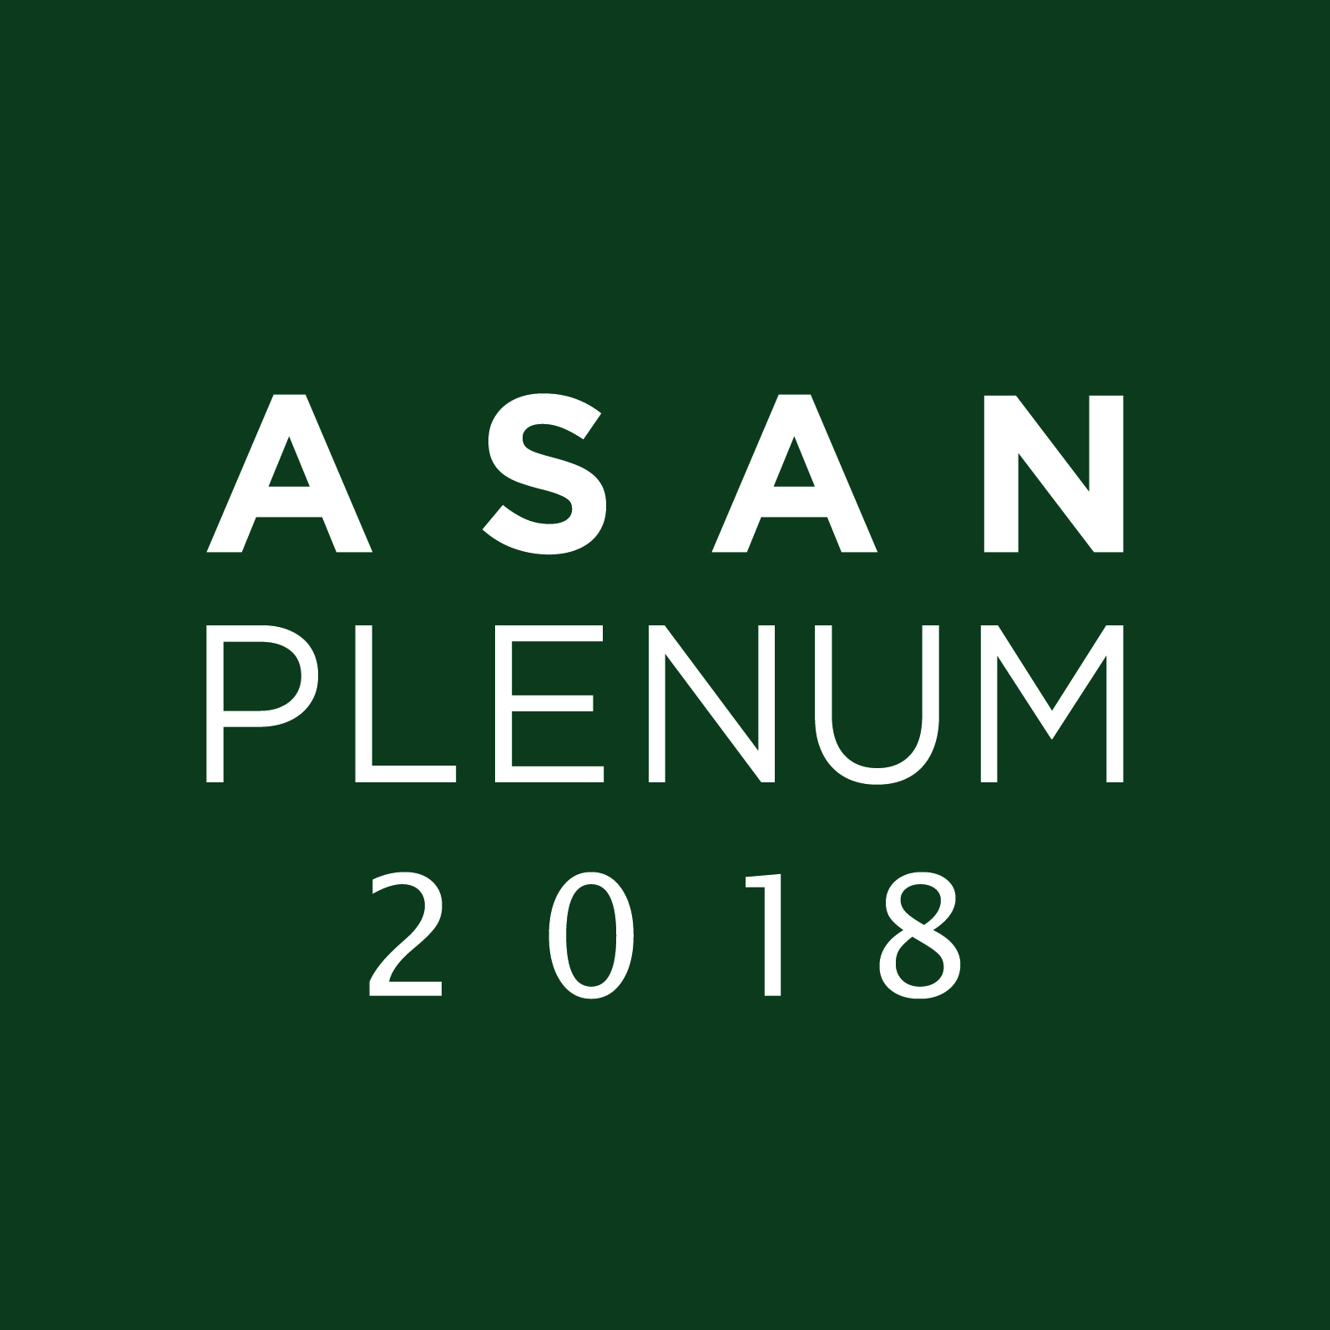

Asan Plenum 2018

“Illiberal International Order”
- Host : The Asan Institute for Policy Studies (http://en.asaninst.org/)
- Title: “Illiberal International Order”
- Date & Time: April 24-25, 2018
  - Day 1 : 09:30~22:30
  - Day 2 : 09:00~17:00
- Venue: The Grand Hyatt Hotel, Seoul, Korea
- Plenum Agenda

Day 1: Tuesday, April 24, 2016
Opening Ceremony
09:30-10:25
Plenary  Session I  10:30-12:00 |  | The Rise and Fall of LIO
Session 1  13:00-14:30 |  | ROK-U.S. Alliance
 |  | Populism v. LIO: U.S.
 |  | One Belt One Road
Plenary  Session II  14:45-16:15 |  | The U.S.-China Strategic Competition
Session 2  16:30-18:00 |  | China, Russia and LIO
 |  | U.S.-Japan Alliance
 |  | Cyber Security
Night Sessions  21:00-22:30 |  | Sharp Power
 |  | Values Diplomacy
Day 2: Wednesday, April 25, 2016
Plenary  Session III  09:00-10:30 | Geoeconomics
Session 3  10:45-12:15 | Indo-Pacific and LIO
 | Populism v. LIO: EU
 | NATO
Lunch & Book Launch
12:15-13:25
Session 4  13:30-15:00 | Northeast Asia and LIO
 | Middle East and LIO
 | Southeast Asia and LIO
Plenary  Session IV  15:15-16:45 | The Outlier: North Korea
16:45-17:00 | Closing Remarks

Appendix 2

Interview Request Form for Asan Plenum 2018
* Please note that should there be more than 4 media requests for a speaker,
the interview will be switched to a Roundtable or a Press Conference.
No. | Speakers | Media | Correspondent | Mobile Number | Email Address | Attendance on  24th or 25th  (Y/N)
1 | Michael Green
1-1 | Book Launch  By More Than Providence  by Michael Green  (12:30-13:25, Wed., Apr. 25th) | Attendance on Book Launch(Y/N):
2 | Bonnie Glaser
3 | Gil Rozman
4 | Martin Fackler
5 | T.J. Pempel
6 | Diederik Vandewalle
7 | Alexander Vershbow
8 | Ravi Velloor
9 | Joseph Kéchichian
10 | Gary Samore
11 | James Lindsay
12 | Mohamed Jawhar
13 | Tanaka Hitoshi
14 | Yamaguchi Noboru
15 | Anna Fifield
16 | Benn Steil
17 | Nishino Junya
18 | Evans Revere
19 | Soeya Yoshihide
20 | Ali Aslan
21 | Philip Stephens
22 | Funabashi Yoichi
23 | Zhao Quansheng
24 | Simon Long
25 | Alexander Lukin
26 | Fukagawa Yukiko
27 | William Overholt
28 | Bruce Bennett
29 | Charles Kupchan
30 | Yukon Huang
31 | Karel De Gucht
32 | Adriana Elisabeth
33 | Hugh White
34 | Walter Russell Mead
35 | Richard Weitz
36 | Kent Calder
37 | Edwin Feulner
38 | François Godement
39 | Douglas Paal
40 | Neal Pollard
41 | Andrei Lankov
42 | Michael Sulmeyer
43 | Patrick Cronin
44 | Mark Lippert
45 | Siavash Saffari
46 | Christopher Walker
47 | Vasil Sikharulidze
48 | Hosoya Yuichi
49 | Peter Harrell
50 | John Park
51 | Paul Wolfowitz
52 | Zhu Feng
53 | Dino Patti Djalal
54 | Ernest Bower
55 | Edward Luce
56 | Daniel Fried
57 | James Steinberg
58 | Wang Dong
59 | Joseph Liow

For the complete list of participants and their bios,
please visit http://en.asaninst.org/events_category/asan-plenum/sub_category/participant-biographies/

Reference 3

‘Asan Plenum 2018: Participants from overseas

U.S.
- Edwin J. Feulner, Founder and Former President, The Heritage Foundation
- Paul Wolfowitz, Visiting Scholar, American Enterprise Institute (AEI); Former President, World Bank; Former Deputy Secretary of Defense
- James Steinberg, Professor of Social Science, International Affairs, Syracuse University; Former Deputy Secretary of State
- Victor Cha, Senior Adviser and Korea Chair at the Center of Strategic and International Studies (CSIS), Director of the Asian studies program at Georgetown University; Former Director for Asian affairs in the National Security Council, The White House
- Daniel Russel, Vice President for International Security and Diplomacy, The Asia Society Policy Institute; Former Assistant Secretary of State for East Asian and Pacific Affairs; Former Senior Director for Asian Affairs in the National Security Council, The White House
- Gary Samore, Executive Director, Harvard Belfer Center; Former Arms Control and Weapons of Mass Destruction (WMD), The White House
- Aaron Friedberg, Professor of Politics and International affairs, Princeton University
- William Overholt, Senior Research Fellow, Asia Center, Harvard University
- Michael Green, Senior Vice President for Asia and Japan Chair, Center for Strategic and International Studies (CSIS); Director of Asian Studies, Georgetown University
- Christopher Nelson, Editor-in-chief, The Nelson Report
- Mark Lippert, Vice President, Boeing International; Former United States Ambassador to the Republic of Korea
- Charles Kupchan, Senior fellow, Council on Foreign Relations (CFR); Professor of International Affairs, Georgetown University; Former Senior Director for European Affairs in the National Security Council, The White House
- David Sanger, Chief Washington Correspondent, The New York Times

China
- Zhu Feng, Executive Director of the China Center and Professor of International Relations, Nanjing University
- Wang Dong, Professor in School of International Studies and Director of the Center for Northeast Asian Strategy, Peking University

Japan
- Funabashi Yoichi, Co-founder and Chairman of Asia Pacific Initiative; Former Editor-in-chief, The Asahi Shimbun
- Fukagawa Yukiko, Professor of Political science and Economics, Waseda University
- Soeya Yoshihide, Professor of Political science, Keio University
- Yamaguchi Noboru, Professor at Graduate School of International Relations, International University of Japan; Former Commanding General of the JGSDF Ground Research and Development Command
- Hosoya Yuichi, Professor of Faculty of Law, Keio University; Senior Fellow, The Tokyo Foundation for Policy Research

Others
- Karel De Gucht, President of the Institute for European Studies, Free University of Brussel(VUB); Former Deputy Prime Minister; Former Minister of Foreign Affairs, Kingdom of Belgium
- Vasil Sikharulidze, Executive Director, Atlantic Council of Georgia; Former Minister of Defense, Georgia
- Dino Patti Djalal, Founder, Foreign Policy Community of Indonesia; Former Presidential Spokesperson; Former Indonesian Ambassador to the U.S., Former Deputy Foreign Minister
- François Godement, Senior Policy Fellow and Director, Asia and China Programme, European Council on Foreign Relations
- Hugh White, Professor of Strategic Studies at the Strategic and Defence Studies Centre, Australian National University
- Mohamed Jawhar, Deputy Director-General, Institute of Strategic and International Studies (ISIS) Malaysia
- Philip Stephens, Associate Editor and Chief Political Commentator, Financial Times
- Ravi Velloor, Associate Editor, The Straits Times
- Alexander Lukin, Director, Center for East Asian and SCO Studies, Moscow State Institute of International Relations, Ministry of Foreign Affairs, Russia
- Mesut Özcan, Deputy Chair of Center for Strategic Research of the Ministry of Foreign Affairs, Republic of Turkey (SAM)
- Alice Ekman, Research Fellow, Center for Asian Studies, French Institute for International Relations (IFRI)

