Press Release
For Immediate Release

Press Conference: Sen. John McCain (R-AZ) and Sen. Sheldon Whitehouse (D-RI)

Seoul, August 26, 2013 – U.S. Sen. John McCain (R-AZ) and Sen. Sheldon Whitehouse (D-RI) will hold press conference at 16:45 on Monday, August 26 in the auditorium at the Asan Institute for Policy Studies.
It is open for the media but R.S.V.P. is required by 12 p.m. Monday, August 26.

For R.S.V.P, please email:
(Ms.) Kahye Oh (communications@asaninst.org)
For more information, please contact:
(Ms.) Heesun Kim (hskim@asaninst.org)

About the Asan Institute for Policy Studies
The Asan Institute for Policy Studies is an independent think tank that provides innovative policy solutions and spearheads public discourse on the core issues in Korea, East Asia and the world. Our goal is to assist policymakers to make better informed and mutually beneficial policy decisions. The Asan Institute, established in 2008, has successfully hosted a series of international conferences including the Asan Plenum, the Asan China Forum and the Asan Nuclear Forum and published a number of books such as China’s Foreign Policy, Japan in Crisis and The Arab Spring.

Biographies

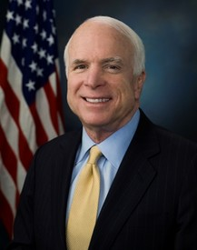
John McCain
John McCain entered the Naval Academy in June of 1954.
He served in the United States Navy until 1981.
He was elected to the U.S. House of Representatives from Arizona
in 1982 and elected to the United States Senate in 1986.

He was the Republican Party’s nominee for president
in the 2008 election.


Sheldon Whitehouse
Sheldon Whitehouse, a graduate of Yale University and
the University of Virginia School of Law, was nominated
by President Bill Clinton to serve as Rhode Island’s
United States Attorney in 1994.
He was the Attorney General of Rhode Island from 1998 to 2003
and elected to the United States Senate in 2006.

