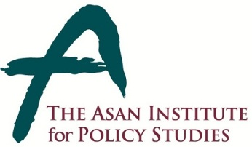 | Press Release
 | March 26, 2014 | For Immediate Release
 | Total of 10 Pages | Contact Points:  Ms Kahye Oh  Ms Heesun Kim
 | 02-3701-7377 | communications@asaninst.org
The Asan Institute To Host Conference on China
“Assessing Its Hard and Soft Power”

- 09:30 on Friday, January 24 in the auditorium at The Asan Institute -

- The Asan Institute for Policy Studies will host the Asan China Conference 2014 under the theme of “Assessing China’s Power” at 9:30AM on Wednesday, April 2, 2014 at the institute.

- The rise of China’s power is a topic of interest throughout the world. Yet, assessing it in a systematic and empirical manner is always a daunting challenge. It will feature sessions on China’s economic/soft power; conventional/nuclear military capabilities; and global, regional, and Chinese perspectives on China's Power.
- It will bring together eminent scholars and experts on China experts from the United States, China, France, the United Kingdom, Australia, Singapore, and Korea to place China’s growing power in perspective.
- The one-day conference consists of 3 sessions as follows: (1) evaluating China’s power in each sector over the past three decades; (2) comparing China’s power with that of the United States; and (3) projecting, on the basis of the former two discussions, the future of China’s power for 2025.

- Due to limited space, media wishing to attend the following event must RSVP to communications@asaninst.org with details including name, affiliation, and mobile number.

* Please be advised that Press Badges will be available at the Press Registration Desk.

About the Asan Institute for Policy Studies
The Asan Institute for Policy Studies is an independent think tank that provides innovative policy solutions and spearheads public discourse on the core issues in Korea, East Asia and the world. Our goal is to assist policymakers to make better informed and mutually beneficial policy decisions. The Asan Institute, established in 2008, has successfully hosted a series of international conferences including the Asan Plenum, the Asan China Forum and the Asan Nuclear Forum and published a number of books such as China’s Foreign Policy, Japan in Crisis, The Arab Spring, Escape From Camp 14 and The Orphan Master’s Son. The Asan Insitute for Policy Studies ranked 6th in "Top 45 Think Tanks in China, India, Japan and the Republic of Korea" and was the only domestic think tank that was selected in the "Best Think Tank Conference" by Think Tanks and Civil Societies Program at the University of Pennsylvania.
Program

09:30-09:45 | Registration
09:45-10:00 | Welcoming Remarks | Hahm Chaibong | The Asan Institute for Policy Studies
09:45-10:00 | Introductory Remarks | Chung Jae-Ho | Seoul National University
Session I  10:00-11:40 | China's Economic/Soft Power
Session I  10:00-11:40 | Presenters | Francois Godement | European Council on Foreign Relations
Session I  10:00-11:40 | Presenters | Scott Kennedy | Indiana University
Session I  10:00-11:40 | Presenters | Kim Hankwon | The Asan Institute for Policy Studies
Session I  10:00-11:40 | Discussants | Shaun Breslin | University of Warwick
Session I  10:00-11:40 | Discussants | Zhao Suisheng | University of Denver
Session I  10:00-11:40 | Discussants | Chen Zhimin | Fudan University
11:45-13:00 | Lunch
Session II  13:00-14:40 | China's Military Capabilities
Session II  13:00-14:40 | Presenters | Andrew Erickson | U.S. Naval War College
Session II  13:00-14:40 | Presenters | Michael Chase | RAND Corporation
Session II  13:00-14:40 | Presenters | Kevin Pollpeter | University of California at San Diego
Session II  13:00-14:40 | Discussants | Linda Jakobson | University of Sydney
Session II  13:00-14:40 | Discussants | You Ji | East Asian Institute, Singapore
14:40-15:00 | Coffee Break
Session III  15:00-18:00 | Global, Regional and Chinese Perspectives on China's Power
Session III  15:00-18:00 | Session III-1 (15:00-16:35) Global and Regional Contexts
Session III  15:00-18:00 | Presenters | Shaun Breslin | University of Warwick
Session III  15:00-18:00 | Presenters | David Kang | University of Southern California
Session III  15:00-18:00 | Presenters | Evelyn Goh | Australian National University
Session III  15:00-18:00 | Discussants | Francois Godement | European Council on Foreign Relations
Session III  15:00-18:00 | Discussants | Scott Kennedy | Indiana University
Session III  15:00-18:00 | Session III-2 (16:35-18:00) Chinese Perspectives
Session III  15:00-18:00 | Presenters | Zhao Suisheng | University of Denver
Session III  15:00-18:00 | Presenters | Chen Zhimin | Fudan University
Session III  15:00-18:00 | Discussants | David Kang | University of Southern California
Session III  15:00-18:00 | Discussants | Evelyn Goh | Australian National University
18:00-18:10 | Concluding Remarks | Chung Jae-Ho | Seoul National University

Participants Biographies

Opening Remarks

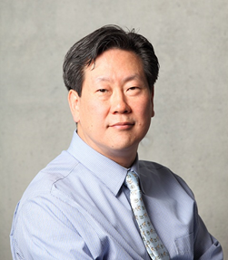
Hahm Chaibong

Chairperson & President
The Asan Institute for Policy Studies

Hahm Chaibong is the President of the Asan Institute for Policy Studies. Previously, he was a Senior Political Scientist at the RAND Corporation (2007-2010), Professor in the School of International Relations and the Department of Political Science as well as the Director of the Korean Studies Institute at the University of Southern California (2005-2007), Director (D-1) of the Division of Social Sciences Research & Policy at UNESCO in Paris (2003-2005), and a Professor in the Department of Political Science at Yonsei University (1992-2005). He has been a Visiting Professor at Duke, Georgetown, and Princeton universities and a Visiting Fellow at the International Forum for Democratic Studies in Washington, D.C. Dr. Hahm is the author of numerous books and articles, including “South Korea’s Miraculous Democracy,” Journal of Democracy (2008), “The Two South Koreas: A House Divided,” The Washington Quarterly (2005), and Confucianism for the Modern World (co-edited with Daniel A. Bell, 2003). Dr. Hahm received a B.A. in economics from Carleton College and an M.A. and Ph.D. in political science from the Johns Hopkins University.

Moderator-Editor

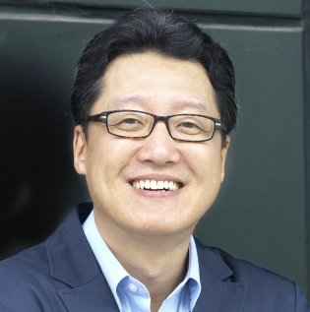
Chung Jae-Ho

Professor
Seoul National University

Chung Jae-Ho is a Professor of Political Science and International Relations, and Director of the Program on U.S.-China Relations at Seoul National University. Professor Chung is a graduate of Seoul National University, Brown University, and the University of Michigan where he earned his doctorate degree in 1993. Before joining Seoul National University in 1996, he taught at the Hong Kong University of Science and Technology during 1993-96. He was also a CNAPS Fellow at the Brookings Institution during 2002-03, and Korea Foundation Visiting Professor at Renmin University of China in 2007. Professor Chung is the author or editor of fourteen books, including Central Control and Local Discretion in China (2000), Between Ally and Partner: Korea-China Relations and the United States (2007), and China’s Crisis Management (2011). Professor Chung is the founding coordinator of the Asian Network for the Study of Local China (ANSLoC: http://www.ansloc.net). Professor Chung is a recipient of Seoul National University’s Best Researcher Award in 2009. Professor Chung also received the Best Research Book Award by the Korean Association for International Studies in 2012.

Presenters and Discussants

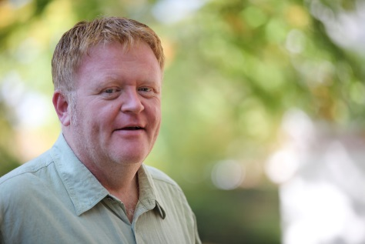
Shaun Breslin

Professor
University of Warwick

Shaun Breslin is a Professor of Politics and International Studies at the University of Warwick in the United Kingdom. He is also an Associate Fellow of the Chatham House Asia Programme at the Royal Institute of International Affairs and co-editor of The Pacific Review. He is currently the coordinator of a major European Commission funded research programme with sixteen global partners that focuses on the EU in a multipolar world. He has published four books, twelve edited collections/special issues, and over 80 refereed articles and chapters in edited collections—primarily on the (international) political economy of contemporary China and studies of comparative regionalism.

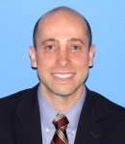
Michael S. Chase

Senior Political Scientist
RAND Corporation

Michael S. Chase is a Senior Political Scientist at the RAND Corporation and an Adjunct Professor in the China Studies and Strategic Studies Departments at Johns Hopkins University's School of Advanced International Studies (SAIS) in Washington, D.C. A specialist in China and Asia-Pacific security issues, he was previously an Associate Professor at the U.S. Naval War College (NWC) in Newport, Rhode Island, where he served as Director of the Strategic Deterrence Group in the Warfare Analysis and Research Department, and taught in the Department of Strategy and Policy. Prior to joining the faculty at NWC, he was a Research Analyst at Defense Group Inc. and an Associate International Policy Analyst at the RAND Corporation. He holds a Ph.D. in international affairs and M.A. in China studies from SAIS, and a B.A. in politics from Brandeis University. In addition, he studied Chinese at the Hopkins-Nanjing Center in Nanjing, China. He is the author of Taiwan's Security Policy, as well as numerous chapters and articles on China and Asia-Pacific security issues. His work has appeared in journals such as Asia Policy, Asian Security, China Brief, Survival, and the Journal of Strategic Studies. His current research focuses on Chinese military modernization, China's nuclear policy and strategy and nuclear force modernization, Taiwan's defense policy, and Asia-Pacific security issues.

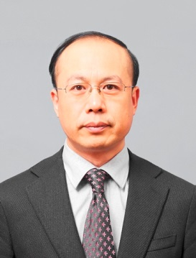
Chen Zhimin

Dean
School of International Relations and Public Affairs
Fudan University

Chen Zhimin is the Dean of the School of International Relations and Public Affairs at Fudan University in Shanghai, China. He is a Professor of International Relations and a Jean Monnet Chair Professor of European foreign policy. He serves as a member on the advisory board or editorial committee of several international journals, including The Hague Journal of Diplomacy and Asia Europe Journal. His research interests include international relations theory, diplomacy studies, Chinese foreign policy, and EU studies. His major publications in Chinese include: China, the United States and Europe: Cooperation and Competition in a New Trilateral Relation (2011); Contemporary Diplomacy (2008); Foreign Policy Integration in European Union: A Mission Impossible? (2003), and Subnational Governments and Foreign Affairs (2001). He also co-edited China's Reforms and International Political Economy with David Zweig (2007). Professor Chen received all of his degrees from Fudan University. He was a Visiting Fellow at Harvard University (1996-1997) and a Visiting Scholar at Queen’s University, University of Durham, Lund University, Sciences Po, and Keio University.

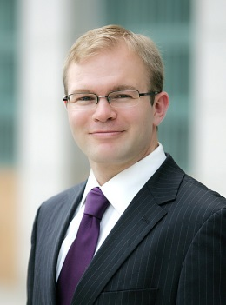

Andrew S. Erikson

Associate Professor
U.S. Naval War College

Andrew S. Erickson is an Associate Professor in the Strategic Research Department at the U.S. Naval War College and a core founding member of the Department’s China Maritime Studies Institute (CMSI). He is an Associate in Research at Harvard University’s John King Fairbank Center for Chinese Studies (2008-present). Dr. Erickson also serves as an expert contributor to the Wall Street Journal’s China Real Time Report (中国实时报) for which he has authored or co-authored 26 articles. In 2013, he was deployed in the Pacific as a Regional Security Education Program Scholar aboard USS Nimitz (CVN68), Carrier Strike Group 11. The National Bureau of Asian Research awarded him the inaugural Ellis Joffe Prize for PLA Studies in 2012. Dr. Erickson was a Fellow in the Princeton-Harvard China and the World Program in residence at Harvard’s Center for Government and International Studies (2010-2011). He was a Fellow in the National Committee on U.S.-China Relations’ Public Intellectuals Program, and served as a scholar escort on a five-Member Congressional trip to Beijing, Qingdao, Chengdu, and Shanghai (2008-11). Dr. Erickson received his Ph.D. and M.A. in international relations and comparative politics from Princeton University, and graduated magna cum laude from Amherst College with a B.A. in history and political science.

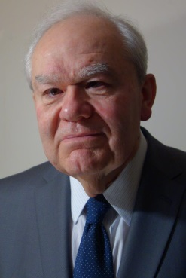
Francois Godement

Director, Asia and China Programme
European Council on Foreign Relations

Francois Godement is a Professor of Political Science at Sciences Po in Paris, Director of the Asia and China Programme at the European Council on Foreign Relations, Research Associate at the Asia Centre, and Nonresident Senior Associate at the Carnegie Endowment for International Peace. He is also an outside consultant to the Policy Planning Directorate of the French Ministry of Foreign Affairs. A long time professor at the French Institute of Oriental Languages and Civilizations, Dr. Godement founded the Asia Centre in 2005 and co-founded the European committee of the Council for Security Cooperation in the Asia-Pacific (CSCAP) in 1995. Dr. Godement received the first Brienne award for the best geopolitical book of the year after publishing Que veut la Chine? De Mao au Capitalism (2012). Other recent publications from the European Council on Foreign Relations include Divided Asia: The Implications for Europe (2013), Xi Jinping’s China (2013), and China at the Crossroads (2012).


Evelyn Goh

Shedden Professor of Strategic Policy Studies
Australian National University

Evelyn Goh holds the Shedden Chair of Strategic Policy Studies at the School of International, Political & Strategic Studies at the Australian National University. Previously, she held faculty positions at Royal Holloway, University of London; the University of Oxford; and the Rajaratnam School of International Studies in Singapore, as well as visiting positions at the Woodrow Wilson Center, East-West Center Washington, and National University of Singapore’s Lee Kuan Yew School of Public Policy. She was an East Asia Institute Fellow in 2011 and a UK Economic & Social Research Council Mid-Career Fellow during 2011-12. She holds masters and doctoral degrees in international relations and an undergraduate degree in geography from the University of Oxford. She has published widely on U.S.-China relations and diplomatic history, regional security cooperation and institutions in East Asia, Southeast Asian strategies towards great powers, and environmental security. These publications include her latest book, The Struggle for Order: Hegemony, Hierarchy and Transition in Post-Cold War East Asia (2013), and Constructing the US Rapprochement with China, 1961-1974: From Red Menace to Tacit Ally (2004).

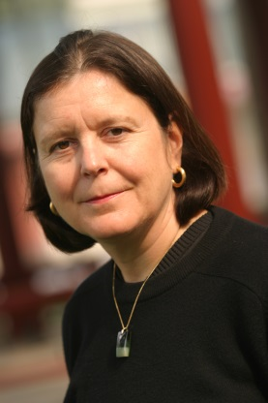
Linda Jakobson

Visiting Professor
The United States Studies Centre
University of Sydney

Linda Jakobson is a Visiting Professor at the United States Studies Centre, University of Sydney as of January 2014. She is also a Nonresident Fellow at the Lowy Institute for International Policy. From 2011 to 2013, she served as Director of the Institute's East Asia Program. Before moving to Sydney in 2011, she lived and worked in China for 20 years and published six books on Chinese and East Asian society. Her last position in Beijing was as Director of the China and Global Security Programme, and Senior Researcher at the Stockholm International Peace Research Institute (SIPRI). A Mandarin speaker, Ms. Jakobson has published extensively on China’s foreign policy, cross-strait relations, China’s energy security, and science & technology polices. Her publications include “Australia's Relations with China in Turbulence” (2014), China's Arctic Aspirations (with Jingchao Peng, 2012), Australia-China Ties: In Search of Political Trust (2011), and New Foreign Policy Actors in China (with Dean Knox, 2010). Ms. Jakobson’s research focuses on China’s foreign and security policy, Northeast Asian political dynamics, maritime security in Indo-Pacific Asia, Australia-China relations, and China's activities in the Arctic.

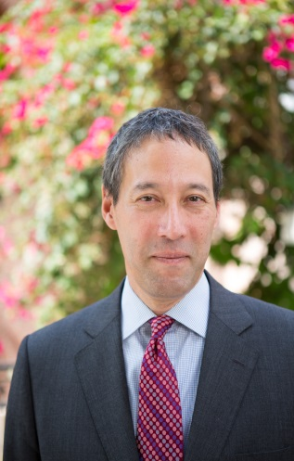

David C. Kang

Professor
University of Southern California

David C. Kang is Professor of International Relations and Business at the University of Southern California (USC) with appointments in both the School of International Relations and the Marshall School of Business. At USC, he directs both the Korean Studies Institute and the East Asian Studies Center. Kang’s latest book is East Asia Before the West: Five Centuries of Trade and Tribute (2010). Kang is also author of China Rising: Peace, Power, and Order in East Asia (2007); Crony Capitalism: Corruption and Development in South Korea and the Philippines (2002), and Nuclear North Korea: A Debate on Engagement Strategies (co-authored with Victor Cha, 2005). A regular consultant for U.S. government agencies, Kang has also written opinion pieces in the New York Times, the Financial Times, the Washington Post, and the Los Angeles Times, and appears regularly in media such as CNN, BBC, and NPR. He received an A.B. with honors from Stanford University and his Ph.D. from University of California, Berkeley.

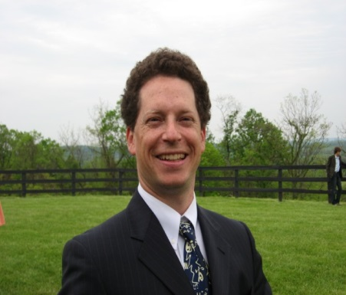
Scott Kennedy

Associate Professor
Indiana University

Scott Kennedy is Director of the Research Center for Chinese Politics & Business, Associate Professor in the Departments of Political Science and East Asian Languages & Cultures, and Adjunct Professor in the Department of Business Economics and Public Policy at the Kelley School of Business, Indiana University. His research examines the role of business interest groups in China through several contexts including lobbying, industrial policy, global governance, and philanthropy. He is author of The Business of Lobbying in China (2005), and editor of China Cross Talk: The American Debate over China Policy since Normalization: A Reader (2003), Beyond the Middle Kingdom: Comparative Perspectives on China’s Capitalist Transformation (2011), and From Rule Takers to Rule Makers: The Growing Role of Chinese in Global Governance (with Shuaihua Cheng, 2012). From late 2011 to early 2014, he also wrote a regular series of reports for GaveKal Dragonomics on China's economic policy process economic policy. He is currently preparing an edited volume, The Dragon's Learning Curve: Global Governance and China (forthcoming, 2014) and writing a monograph, Mandarins Playing Capitalist Games: How Chinese Are Reshaping Global Governance. He earned a Ph.D. from George Washington University.

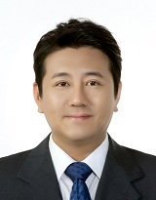

Kim Hankwon

Research Fellow
The Asan Institute for Policy Studies

Kim Hankwon is a Research Fellow and the Director of the Center for Regional Studies at the Asan Institute for Policy Studies. Previously, he was a Visiting Professor in the Center for Chinese Studies at the Korean National Diplomatic Academy, a Research Fellow in the Institute of International Strategy and Development at Tsinghua University, and a Research Scholar at the School of International Studies at Peking University. Dr. Kim specializes in Chinese foreign policy and nationalism as well as Sino-North Korean economic relations. His recent publications include “The Multilateral Economic Cooperation for Tumen River Area and China’s Leadership,” The Korean Journal of International Relations (2010) and “China’s Strategic Response to the Kim Jong-un Regime,” IFANS Focus (2012). He received a B.A. and M.P.A. (Master of Public Affairs) from the University of Connecticut at Storrs, and his Ph.D. in International Relations from American University. Dr. Kim also completed a post-doctoral program at Tsinghua University.

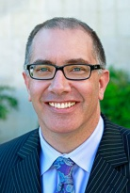
Kevin Pollpeter

Deputy Director
Institute on Global Conflict and Cooperation
University of California, San Diego

Kevin Pollpeter is Deputy Director of the University of California Institute on Global Conflict and Cooperation (IGCC) Project on the Study of Innovation and Technology in China (SITC). Prior to IGCC, he was Deputy Director of the East Asia Program at Defense Group Inc., and a Researcher at the RAND Corporation. Professor Pollpeter is widely published on China national security issues with a focus on China’s space program and information warfare. His space-related publications include the monograph Building for the Future: China’s Progress in Space Technology During the Tenth Five-year Plan and the U.S. Response, and a book chapter titled “The Chinese Vision of Space Military Operations.” He has also written frequently for China Brief. Professor Pollpeter has coauthored works including Dangerous Thresholds: Managing Escalation in the 21st Century and Entering the Dragon’s Lair: Chinese Anti-access Strategies and Their Implications for the United States. A Chinese linguist, he holds an M.A. in international policy studies from the Monterey Institute of International Studies and is currently enrolled in a doctorate program at King’s College, London.

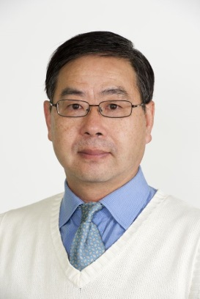
You Ji

Visiting Senior Research Fellow
East Asian Institute
National University of Singapore

You Ji is currently a visiting Senior Research Fellow at the East Asian Institute, National University of Singapore. He graduated from Peking University and Australian National University. Dr. You has authored three books including The Armed Forces of China, and has written numerous articles. His most recent papers include “The Politics of CCP Council of State Security” (forthcoming, 2014), “The PLA and Diplomacy: Unrevealing Myths about the Military Role in Foreign Policy-Making” (2014), “The Roadmap of Upward Advancement for PLA Leaders”, in Zang Xiaowei and Kou Chien-wen (eds.), Choosing Chinese Leaders (2014), “Politics in command of Beijing’s military policy toward Taiwan: the foundation for consolidating rapprochement”, in Weixing Hu (ed.), New Dynamics in Cross-Taiwan Straits Relations: How far can the rapprochement go? (2013), and “Meeting the Challenge of Asia’s Changing Security Environment: China’s Response to the New Security Threats”, in Eiichi Katahara (ed.), Security Outlook of the Asia-Pacific Countries and Its Implications for the Defense Sector (2013).

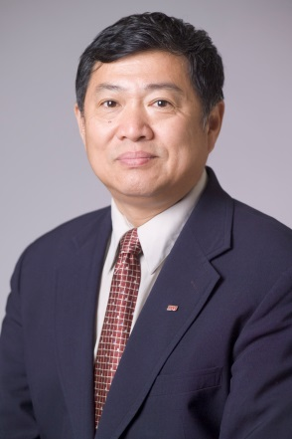
Zhao Suisheng

Professor
Josef Korbel School of International Studies
University of Denver

Zhao Suisheng is Professor and Director of the Center for China-US Cooperation at Josef Korbel School of International Studies at the University of Denver. He is currently a member of the Board of Governors of the US Committee of the Council for Security Cooperation in the Asia Pacific, a member of National Committee on US-China Relations, a Campbell National Fellow at Hoover Institution of Stanford University, and a Research Associate at the Fairbanks Center for East Asian Research in Harvard University. Dr. Zhao is also the Founder and Chief Editor of the Journal of Contemporary China. He was Associate Professor of Political Science and International Studies at Washington College in Maryland, Associate Professor of Government and East Asian Politics at Colby College in Maine and visiting Assistant Professor at the Graduate School of International Relations and Pacific Studies (IR/PS) at University of California, San Diego. He received a Ph.D. in political science from the University of California, San Diego, his M.A. in sociology from the University of Missouri, and B.A. and M.A. degrees in economics from Peking University. He is the author and editor of more than ten books, including The Rise of China and Transformation of the US-China Relationship: Forging Partnership in the Age of Strategic Mistrust (2013), and China’s Search for Energy Security: Domestic Sources and International Implications (2012).

