Press Release
For Immediate Release

KOREA GLOBAL FORUM 2013
Seoul Workshop

Seoul, November 19, 2013 – The Ministry of Unification and the Asan Institute for Policy Studies will co-host the KOREA GLOBAL FORUM 2013 on Wednesday, November 20 at the Westin Chosun Hotel in Seoul.

This year’s Forum, titled “The Korean Peninsula Trust-building Process: Challenges and Opportunities,” brings together leading experts, policymakers, scholars, and members of the media to share their insights on the past, present, and future of inter-Korean relations and the broader changes in a global context.

High-level speakers will include:
- Dr. Ryoo Kihl-jae, Minister of Unification, Ministry of Unification, ROK
- Mr. Ju Chul-ki, Senior Secretary for Foreign Affairs and National Security, ROK
- Prof. John Ikenberry, Albert G. Milbank Professor of Politics and International Affairs, Princeton University
- Prof.Wang Yizhou, Vice Dean, School of International Studies, Peking University

For more details, please visit: www.kgf2013.org.

To register, send your name, affiliation, and mobile number to: communications@asaninst.org
* R.S.V.P. is required for the Press. Press Cards will be issued on the day.

About the KOREA GLOBAL FORUM
Established by the Ministry of Unification of the Republic of Korea, the Korea Global Forum gathers current and former high-level officials and experts to participate in a 1.5 track multilateral dialogue led by South Korea to discuss the pending issues of the Korean Peninsula and the region.

About the Asan Institute for Policy Studies
The Asan Institute for Policy Studies is an independent think tank that provides innovative policy solutions and spearheads public discourse on the core issues in Korea, East Asia and the world. Our goal is to assist policymakers to make better informed and mutually beneficial policy decisions. The Asan Institute, established in 2008, has successfully hosted a series of international conferences including the Asan Plenum, the Asan China Forum and the Asan Nuclear Forum and published a number of books such as China’s Foreign Policy, Japan in Crisis and The Arab Spring.

KOREA GLOBAL FORUM 2013
Seoul Workshop

1. Host : The Ministry of Unification and The Asan Institute for Policy Studies
2. Title : “The Korean Peninsula Trust-building Process : Challenges and Opportunities”
3. Date and Time : Wednesday, November 20, 2013 (Wed) 09:30 to 17:00
4. Venue : Orchid Room(2nd Floor) at the Westin Chosun
5. Conference Agenda :
Wednesday, November 20, 2013 (Open Sessions)
Time | Panel Title | Panelist |  | Affiliation
09:00-09:30 | Registration
09:30-09:40 | Welcoming Remarks | Hahm Chaibong |  | The Asan Institute for Policy Studies
09:40-10:20 | Keynote Speech | Ryoo Kihl-jae |  | Ministry of Unification, ROK
10:20-10:30 | Break
Session I  10:30-11:45 | Inter-Korea Relations in the Evolving Global Context
 | Speakers | Hahm Chaibong |  | The Asan Institute for Policy Studies
 |  | John Ikenberry |  | Princeton University
 |  | Wang Yizhou |  | Peking University
11:45-13:30 | Lunch  Speech by Ju Chul-ki, Senior Secretary for Foreign Affairs and National Security, ROK
Session II  13:30-15:10 | The Korean Peninsula Trust-Building Process
 | Moderator | Choi Kang | The Asan Institute for Policy Studies
 | Speakers | Chun Hae Sung | Ministry of Unification, ROK
 |  | Chu Shulong | Tsinghua University
 |  | David Kang | University of Southern California
 |  | Vasily Mikheev | IMEMO
 |  | Lars-André Richter | Friedrich Naumann Foundation
 |  | Togo Kazuhiko | Kyoto Sangyo University
15:10-15:30 | Break
Session III  15:30-17:10 | DMZ Peace Park
 | Moderator | Woo Jung-Yeop | The Asan Institute for Policy Studies
 | Speakers | Lee Kang-Woo | Ministry of Unification, ROK
 |  | John Everard | Former UK Ambassador to DPRK
 |  | Michishita Narushige | National Graduate Institute for Policy Studies
 |  | Scott Snyder | Council on Foreign Relations
 |  | Brendan Taylor | Australian National University
 |  | Zhu Feng | Peking University

6. Speakers :

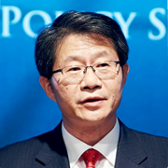
Ryoo Kihl-jae
Minister, Ministry of Unification of the Republic of Korea
H.E. Dr. Ryoo is Minister of Unification of the Republic of Korea. Before his ministerial appointment in 2013, he held the position of President of the Korean Association of North Korean Studies and was a member of the Diplomacy and Security Division at the Ideas for Korea. His professional career spans around two decades of academic lecturing and research in the field of North Korea studies. They include Professor and Assistant Professor at the University of North Korean Studies, Policy Advisor to the Ministry of Unification, Standing Council Member of the National Unification Advisory, Policy Advisor for the President on Foreign Affairs and National Security, Professor at Kyungnam University, and Researcher at the Institute for Far Eastern Studies. Dr. Ryoo’s complimentary academic pursuits include a B.A. and M.A. in political science from Korea University in 1984 and 1987, respectively. He later completed a Ph.D. in political science at the same university in 1995.
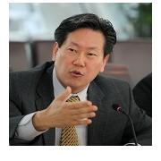
Hahm Chaibong
President, The Asan Institute for Policy Studies
Dr. Hahm is the president of the Asan Institute for Policy Studies. Previously, he was a senior political scientist at the RAND Corporation (2007-2010), professor in the School of International Relations and the Department of Political Science as well as the director of the Korean Studies Institute at the University of Southern California (2005-2007), director (D-1) of the Division of Social Sciences Research & Policy at UNESCO in Paris (2003-2005), and a professor in the Department of Political Science at Yonsei University (1992-2005). He has been a visiting professor at Duke, Georgetown, and Princeton universities and a visiting fellow at the International Forum for Democratic Studies in Washington, D.C. Dr. Hahm received a B.A. in economics from Carleton College and an M.A. and Ph.D. in political science from the Johns Hopkins University.
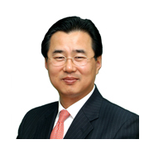
Choi Kang
Vice President, The Asan Institute for Policy Studies
Dr. Choi is a Senior Research Fellow and the Vice President of the Asan Institute for Policy Studies. Prior to joining the Asan Institute, he was the dean of Planning and Assessment at the Korea National Diplomatic Academy. He also previously worked at the Institute for Foreign Affairs and National Security as a professor and director-general for American Studies. From 1992 to 1998, and from 2002 to 2005, Dr. Choi worked in the Korea Institute for Defense Analyses. From 1998 to 2002, he served in the National Security Council Secretariat as senior director for Policy Planning and Coordination. He holds several advisory board memberships including: the Committee on Foreign Affairs, Trade, and Unification in the National Assembly; the Ministry of National Defense; the Ministry of Unification; the Air Force Development Committee; and the National Unification Advisory Council. Dr. Choi was also a South Korean delegate to the Four-Party Talks. He received his Ph.D. from Ohio State University.

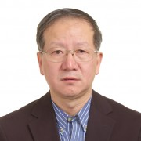
Chu Shulong
Deputy Director, Institute of International Strategic and Development Studies, Tsinghua University
Dr. Chu Shulong is a Professor of Political Science and International Relations at the School of Public Policy and Management and is the deputy director of the Institute of International Strategic and Development Studies at Tsinghua University in Beijing, China. He was previously director for the North American Studies Division of the China Institute of Contemporary International Relations. He is also a Professor at China’s Ministry of Foreign Affairs’ Party School and an advisor to China’s Central Television (CCTV) international reporting. He was visiting scholar at the Center for U.S.-China Relations of New York University in January 2013, a senior visiting fellow at the Brookings Institution in 2006-2007, and the East-West Center in 2001. Dr. Chu’s major areas of research are international relations, US foreign strategy and China policy, the Sino-US relations, and China’s foreign and security strategies. His most recent publications include The Sino-US Relations in the Post-Cold War Era; Basic Theories of International Relations; and China’s Foreign Strategy and Policy, and American Government and Politics (three volumes).

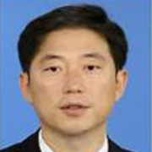
Chun Hae Sung
Assistant Minister for Unification Policy, Ministry of Unification, ROK
Mr. Chun is the Assistant Minister for Unification Policy at the Ministry of Unification, Republic of Korea. Before this post, he served as Senior Representative for Inter-Korean Dialogue. Since joining the Ministry of Unification in 1987, Mr. Chun has held several other positions including Spokesperson of the Ministry (2009); Director General of the Humanitarian Cooperation Bureau (2008); and Director of the Inter-Korean Dialogue Planning Department (2006). Outside of the Ministry, Mr. Chun was the Executive Officer at the National Security Council (2003). He received his M.A. in Public Administration and B.A. in Public Law from Seoul National University.

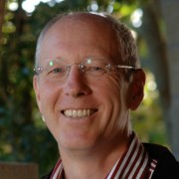
John Everard
Former UK Ambassador to DPRK
Over a 27 year career with the UK diplomatic service John Everard served in a variety of countries, including as Ambassador to Belarus and later as Ambassador to Uruguay. His final assignment was as British Ambassador to the DPRK, resident in Pyongyang, from February 2006 to July 2008. After retiring from the UK diplomatic service he was Pantech Visiting Fellow at the Shorenstein Asia-Pacific Research Center of Stanford University where he published a book “Only Beautiful, Please” describing his experiences of living in Pyongyang. In 2011-12 he coordinated the UN Panel of Experts that advises on improving implementation of UN sanctions against the DPRK. He continues to comment on the DPRK in the UK media.

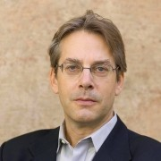
G. John Ikenberry
Albert G. Milbank Professor of Politics and International Affairs, Princeton University
Professor Ikenberry is the Albert G. Milbank Professor of Politics and International Affairs at Princeton University. He is also the co-director of Princeton University’s Center for International Security Studies and is the Global Eminence Scholar at Kyung Hee University in Seoul, Korea. He served as a member of an advisory group at the US State Department and as a member of the Council on Foreign Relations’ Henry Kissinger-Lawrence Summers Commission on the Future of Transatlantic Relations. His publications include, Liberal Leviathan: The Origins, Crisis, and Transformation of the American World Order (Princeton University Press, 2011) and “Liberalism in a Realist World” (International Studies, 2009). He received his B.S. in political science and philosophy from Manchester College and M.A. and Ph.D. in political science from the University of Chicago.

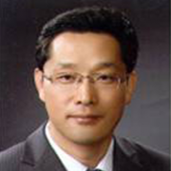
Lee Kang-Woo
Director General, Ministry of Unification, ROK
Mr. Lee is a Director General at the Ministry of Unification, currently heading the Task Force for the DMZ Peace Park. Prior to this post, he held several positions including the Director General of the National Committee on Investigating Abductions during the Korean War and the General Management Director at the Inter-Korean Cooperation District Support Directorate. Since passing the Higher Civil Service Examination in 1990 to serve the Ministry of Unification, he also undertook tasks in areas of international cooperation, economic and social analysis, general analysis, and national security at the Senior Secretary Office to the President for Foreign Affairs and National Security. Mr. Lee’s complimentary academic pursuits include a B.A. in marine engineering and naval architecture at Pusan National University and an M.A. in public administration at Florida State University in 1987 and 2005, respectively. He also studied public administration at Seoul National University’s Graduate School of Public Administration.

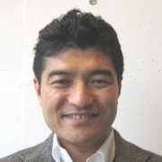
Narushige Michishita
Associate Professor, National Graduate Institute for Policy Studies (GRIPS)
Professor Michishita is associate professor and the director of the Security and International Studies Program at GRIPS. Previously, he served as senior research fellow at the National Institute for Defense Studies (NIDS), Ministry of Defense and assistant counsellor at the Cabinet Secretariat for Security and Crisis Management of the Government of Japan. He acquired his Ph.D. from the School of Advanced International Studies (SAIS), Johns Hopkins University. A specialist in Japanese security and foreign policy as well as security issues on the Korean Peninsula, his works include North Korea’s Military-Diplomatic Campaigns, 1966-2008 (Routledge, 2010).

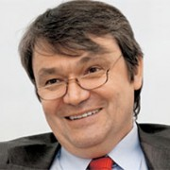
Vasily Mikheev
Vice President, Institute of World Economy and International Relations (IMEMO)
Dr. Mikheev is the Vice President of IMEMO at the Russian Academy of Sciences. He was previously the First Secretary of the Russian Embassy to North Korea (1981-1984), a researcher for the Institute for the Economy of the World Socialist System (1984-1993), Councilor and head of the Political Section at the Russian Embassy in Lithuania (1993-1996), Deputy Director of the Institute for Far Eastern Studies (1999-2005), and Director of the Asia Security Program at the Carnegie Moscow Center (2003-2005). Dr. Mikheev was also the Asia-Pacific Economic Cooperation coordinator for Russia (1998), Director of the China & Japan Studies Center at IMEMO (2005), member of the Directors’ Board of IMEMO (2007), and a member of the Russian Council for Defense and Foreign Policy (2006). He graduated from the Moscow State Institute for International Relations and holds a Doctor of Economic Science degree (1992) and a Candidate of Economic Science degree (1978).
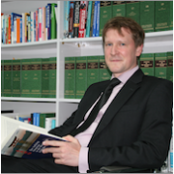
Lars-André Richter
Resident Representative, Friedrich Naumann Foundation for Freedom, Korea
Dr. Richter is the Resident Representative of the Friedrich Naumann Foundation for Freedom in Korea since June 2012. He studied amongst others German Literature, Philosophy and History in Tübingen, Leipzig, Paris (Paris III – Sorbonne Nouvelle) and Berlin. He earned his Ph.D. from Humboldt University in Berlin in 2008 with his doctoral dissertation on the Weimar Republic. He has been working for the FNF since 2008. He served as Press Officer and Deputy Spokesman at the Foundation’s headquarters in Potsdam before the current post. Prior to joining FNF, he also worked for the DAAD (Deutscher Akademische Austauschdienst/German Academic Exchange Service), amongst others in Mexico-City, and later for WELT ONLINE, the online edition of the German daily newspaper ”Die Welt”.

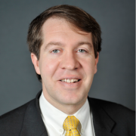
Scott Snyder
Senior Fellow for Korea Studies, Council on Foreign Relations
Mr. Snyder is a senior fellow for Korea Studies and the director of the program on U.S.-Korea Policy at the Council on Foreign Relations. He is the editor of Global Korea: South Korea`s Contributions to International Security and The U.S.-South Korea Alliance. He previously worked at The Asia Foundation between 2000 and 2011, where he served as representative in Seoul and directed the foundation’s Center for U.S.-Korea Policy. He has also worked for the U.S. Institute of Peace and The Asia Society. He received a B.A. from Rice University and an M.A. in East Asian Regional Studies from Harvard University.
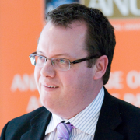
Brendan Taylor
Head, Strategic & Defence Studies Centre, Australian National University
Dr. Taylor is Head of the Strategic and Defence Studies Centre, Australian National University. He is a specialist on great power strategic relations in the Asia-Pacific, economic sanctions, and Asian security architecture. His publications have featured in such leading journals as International Affairs, Survival, Asian Security, Review of International Studies and the Australian Journal of International Affairs. He is the author of Sanctions as Grand Strategy, which was published in the International Institute for Strategic Studies (IISS) Adelphi series, as well as American Sanctions in the Asia Pacific (Routledge, 2010). He is also the editor of Australia as an Asia-Pacific Regional Power (Routledge, 2007), Insurgent Intellectual: Essays in Honour of Professor Desmond Ball (ISEAS, 2012) and Bilateralism, Multilateralism and Asia-Pacific security (Routledge, 2013).

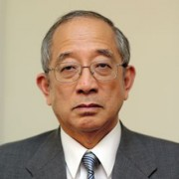
Togo Kazuhiko
Director of the Institute for World Affairs, Kyoto Sangyo University
Ambassador Togo is Professor and Director of the Institute for World Affairs, Kyoto Sangyo University since 2010. He served in the Japanese Foreign Ministry from 1968 to 2002, working on Russia, the US, Europe, international law and economics and retired as Ambassador to the Netherlands. Ambassador Togo taught at universities abroad and in Japan, including Princeton and Seoul National University. His recent publication includes in English Japan’s Foreign Policy 1945-2009 and in Japanese The Inside Story of the Negotiations on the Northern Territories; History and Foreign Policy: Yasukuni, Asia and Tokyo Tribunal; What Japan lost after WWII: Scenery, Human Being and State and Questionning historical recognition: Yasukuni, Comfort Women, and Territorial Issues. He received his Ph.D. from Leiden University in 2009.

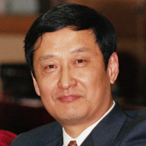
Wang Yizhou
Associate Dean, School of International Studies (SIS), Peking University
Dr. Wang is Associate Dean of the School of International Studies (SIS) and Professor of international politics and Chinese foreign affairs at Peking University. He previously served as Deputy Director of the Institute of World Economics and Politics at the Chinese Academy of Social Sciences (CASS) (1998-2009) where he also served as Associate Professor and researcher (1988-1993). He was a visiting scholar of Harvard University (1996-1997). Dr. Wang graduated from Hubei University in Wuhan, China and received his M.A. and Ph.D. degrees from the CASS Graduate School. His most recent publications include Creative Involvement: The Evolution of China’s Global Role (2013, in Chinese), Creative Involvement: The New Direction of China Diplomacy (2011, in Chinese); Highland of China Foreign Policy (2008, in Chinese); and New Thinking of China’s Diplomacy (2007, in Japanese). Dr. Wang’s main areas of research are China’s diplomacy, International Relations theory in China and the West, and trends in international institutions and laws.
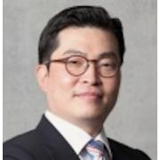
Woo Jung-Yeop
Director, Center for Security Policy, The Asan Institute for Policy Studies
Dr. Woo is a Research Fellow and the Director of the Center for Security Policy at the Asan Institute for Policy Studies. Previously, he was a postdoctoral fellow at the Korean Studies Institute at the University of Southern California. He was also an Associate Analyst for Gallup Korea and the Korea Research Company. His areas of specialty include foreign military intervention in civil wars and the relationship between foreign policy-making and public opinion. His most recent publication is Korean Voters’ Decision: On the 2012 General Election (in Korean, co-edited with Park Chanwook and Kim Jiyoon). Dr. Woo received his B.A. in business administration from Seoul National University, an M.P.P. from Georgetown University, and a Ph.D. in Political Science from the University of Wisconsin-Milwaukee.

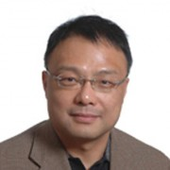
Zhu Feng
Professor, School of International Studies, Peking University
Dr. Zhu is a professor at the School of International Studies and is the deputy director of the Center for International and Strategic Studies at Peking University. He sits on a number of editorial boards of scholarly journals and is a member of the Beijing Committee of the Chinese People’s Political Consultative Conference. He is also a senior research fellow at the China Institute of Peace and Development. He writes extensively on regional security in East Asia, the North Korean nuclear issue, U.S. national security strategy, and the military and security dimensions of China-U.S. relations. His recent books include Ballistic Missile Defense and International Security; International Relations Theory and East Asian Security; and China’s Ascent: Power, Security, and the Future of International Politics (co-edited with Robert S. Ross). Professor Zhu began his undergraduate studies in the Department of International Politics at Peking University in 1981 and received his Ph.D. from Peking University in 1991.

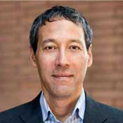
David Kang
Professor, University of Southern California
Dr. Kang is Professor of International Relations and Business at the University of Southern California, with appointments in both the School of International Relations and the Marshall School of Business. At USC he is also director of the Korean Studies Institute. Dr. Kang’s latest book is East Asia Before the West: Five Centuries of Trade and Tribute (Columbia University Press, 2010). He is also author of China Rising: Peace, Power, and Order in East Asia (Columbia University Press, 2007); Crony Capitalism: Corruption and Development in South Korea and the Philippines (Cambridge University Press, 2002), and Nuclear North Korea: A Debate on Engagement Strategies (co-authored with Victor Cha) (Columbia University Press, 2003). Dr. Kang has published numerous scholarly articles in journals such as International Organization and International Security, and his co-authored article “Testing Balance of Power Theory in World History” was awarded “Best article, 2007-2009,” by the European Journal of International Relations. Dr. Kang has also written opinion pieces in The New York Times, The Financial Times, The Washington Post, and The Los Angeles Times, as well as writing a monthly column for The Joongang Ilbo in Korean. He received an A.B. with honors from Stanford University and his Ph.D. from UC Berkeley.

