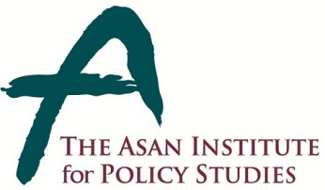 | Press Release
 | January 2, 2014 | For Immediate Release
 | Total of 1 Page | Contact Point:  Ms Heesun Kim
 | 02-3701-7387 | communications@asaninst.org

The Asan Institute Announces Appointment of Senior Advisor

- The Asan Institute for Policy Studies is pleased to announce the appointment of Chun Yung-woo, the former chief secretary of the Foreign Affairs and Security department in the Office of the President of the Republic of Korea, to the position of a senior adviser, effective Thursday, January 2, 2014.

- Dr. Chun, a career diplomat and skilled negotiator, brings a wealth of experience and knowledge after serving more than 30 years in various key positions in foreign affairs and national security areas.

- Born in Milyang, South Gyeongsang Province, in 1952, he served as Seoul’s chief negotiator for the six-party talks on ending North Korea’s nuclear program from 2006 to 2008 before assuming the post of second vice minister in the Ministry of Foreign Affairs and Trade. Chun also worked with the South Korean mission in the United Nations and served as ambassador to the United Kingdom.

- He studied French literature at Pusan National University and obtained a master’s degree in international relations at Columbia University in New York.

About the Asan Institute for Policy Studies

The Asan Institute for Policy Studies is an independent think tank that provides innovative policy solutions and spearheads public discourse on the core issues in Korea, East Asia and the world. Our goal is to assist policymakers to make better informed and mutually beneficial policy decisions.

The Asan Institute, established in 2008, has successfully hosted a series of international conferences including the Asan Plenum, the Asan China Forum and the Asan Nuclear Forum. It has also published a number of books such as China’s Foreign Policy, Japan In Crisis, and The Arab Spring.

