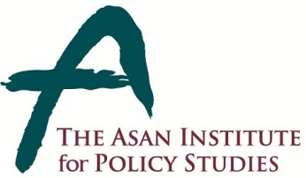 | Press Release
 | May 23, 2014 | For Immediate Release
 | Total of 3 Pages | Contact Points:  Ms Heesun Kim
 | 02-3701-7387 | communications@asaninst.org
The Asan Institute Hosts Roundtable with the Hon. Michael Kirby
- 12 pm on Friday, May 30 at the Institute
        - Media Q&A Session at 13:30

- The Asan Institute for Policy Studies will host a roundtable with the Hon. Michael Kirby, Chair of the Commission of Inquiry (COI) on Human Rights in North Korea at 12 pm on Friday, May 30 at the institute.

- He will present the findings of the COI as outlined in the recently published U.N. report. Korean experts including Dr. Shin Chang-Hoon, Dr. Jang Ji-Hyang, Dr. Go Myong-Hyun from the institute and Prof. Hong Sung-Pil will join him to discuss follow-up measures in light of the Commission’s work.

- The report released in February revealed compelling evidence of the human rights violations committed by the regime.

* Credentialed members of the press who would like to attend must RSVP to communications@asaninst.org with details including name, affiliation, and mobile number.

About the Asan Institute for Policy Studies
The Asan Institute for Policy Studies is an independent think tank that provides innovative policy solutions and spearheads public discourse on the core issues in Korea, East Asia and the world. Our goal is to assist policymakers to make better informed and mutually beneficial policy decisions. The Asan Institute, established in 2008, has successfully hosted a series of international conferences including the Asan Plenum, the Asan China Forum and the Asan Nuclear Forum and published a number of books such as China’s Foreign Policy, Japan in Crisis, The Arab Spring, Escape From Camp 14 and The Orphan Master’s Son. The Asan Insitute for Policy Studies ranked 6th in "Top 45 Think Tanks in China, India, Japan and the Republic of Korea" and was the only domestic think tank that was selected in the "Best Think Tank Conference" by Think Tanks and Civil Societies Program at the University of Pennsylvania.

Appendix 1

Roundtable with Michael Kirby

1. Date and Time: Friday, May 30, 2014 / 12:00 ~ 14:30
2. Venue: Conference Room (2F), The Asan Institute for Policy Studies
3. Agenda:
North Korean human rights situation and the findings of the UN COI
4. Program
Time | Program
12:00 - 13:30 | Roundtable
13:30 - 14:30 | Media Q&A Session

5. Participants
- Shin Chang-Hoon
Director of the Center for Global Governance, Asan Institute
- Go Myong-Hyun
Research Fellow in Center for Public Opinion and Quantitative Research, Asan Institute
- Jang Ji-Hyang
Research Fellow in Center for Regional Studies, Asan Institute
- Hong Sung-Pil
Yonsei University
- Baek Buhm-Suk
Kyunghee University

Appendix 2

Short Bio of Michael Kirby

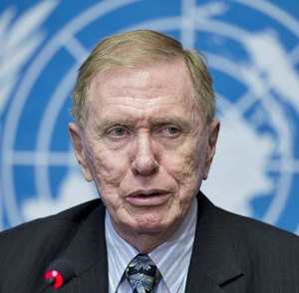

- Former Justice of the High Court of Australia (1996-2009) and President of the Court of Appeal of Solomon Islands (1995-1996)

- President of the International Commission of Jurists (1995-98); Member of UNESCO International Bioethics Committee (1996); Member of the World Health Organisation’s Global Commission on AIDS (1988-1991)

- Special Representative of UN Secretary-General for Cambodia (1994-96)

- Special concerns: human rights, the rule of law, the independence of the judiciary and the impact of science and technology on society and its laws

- Awards: eighteen honorary doctorates at home and abroad; and the Gruber Justice Prize (2010)

