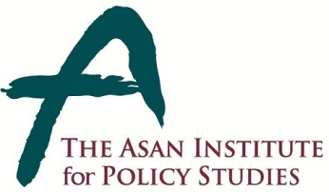 | Press Release
 | October 13, 2014 | For Immediate Release
 | Total of 1 Page | Contact Point:  Ms Heesun Kim
 | 02-3701-7387 | communications@asaninst.org

High support among S. Korean public for inter-Korean summit

- From September 4-6 & October 6-8, 2014 the Asan Institute for Policy Studies conducted public opinion surveys on attitudes towards North Korea and reunification.
- Overall, the data shows that little was changed by the recent surprise visit of a high-ranking North Korean delegation.
- In October, a clear majority (81.7%) stated that a South-North summit was necessary. This was virtually unchanged from the September survey when 81.2% were in support.
- In the most recent survey, 72.9% stated that reunification should be based on circumstances. Only 13.8% stated reunification should take place as soon as possible. In September, those numbers were 70.6% and 16.0%, respectively.
- Even if it hurt the South Korean economy, 45.5% voiced support for reunification while 43.9% opposed. [September 4-6]
- A plurality (45.0%) supported the recent surprise meetings between the South and North. 24.9% opposed. [October 6-8]
- In the October survey, 31.5% supported lifting the May 24 sanctions and 23.5% opposed. However, a plurality (44.4%) was uncertain. In September, 34.0% were in support, 26.6% in opposition, and 38.9% uncertain.
- Just 18.8% supported unconditional economic aid to North Korea in the October survey. 71.2% would support economic aid if North Korea changed its behavior. Again, this was largely unchanged from September when those numbers were 22.5 and 67.8%, respectively.
- A majority (63.1%) supported reopening tours to Mt. Geumgang in the October survey. In September, that number was 64.4%.
- The sample size of the survey was 1,000 people over the age of 19. The margin of error was ±3.1% at the 95% confidence level. The survey employed RDD for landline and mobile telephones.

About the Asan Institute for Policy Studies
The Asan Institute for Policy Studies is an independent think tank that provides innovative policy solutions and spearheads public discourse on the core issues in Korea, East Asia and the world. Our goal is to assist policymakers to make better informed and mutually beneficial policy decisions.

The Asan Institute, established in 2008, has successfully hosted a series of international conferences including the Asan Plenum, the Asan China Forum and the Asan Nuclear Forum. It has also published a number of books such as China’s Foreign Policy, Japan In Crisis, and The Arab Spring.

