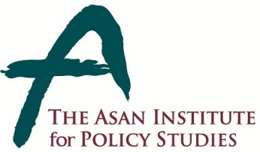 | Press Release
 | November 18, 2014 | For Immediate Release
 | Total of 1 Page | Contact Point:  Ms Heesun Kim
 | 02-3701-7387 | communications@asaninst.org
Majority Support for the Korea-China FTA

- From November 14-6, 2014 the Asan Institute for Policy Studies conducted a public opinion survey on attitudes towards the recently signed Korea-China FTA.
- A slim majority (54.3%) supported the Korea-China FTA. In May 2012, support for a Korea-China FTA was 46.5%.
- While 37.7% thought China would benefit most from the FTA, 37.7% thought Korea and China would benefit equally. Only 11.5% thought Korea would benefit most. In July 2014, 21.5% thought China would benefit most. While 48.9% thought both countries would benefit equally, 6.7% thought Korea would benefit most.
- In comparison, 44.0% thought the US benefitted more from the Korea-US FTA. While 28.0% thought both countries benefitted equally, 13.3% thought Korea benefitted most.
- Despite overall support, 60.2% wanted the National Assembly—which must still ratify the agreement—to investigate the agreement carefully. Only 20.6% thought it should be ratified as quickly as possible.
- The country of origin effect was noticeable in the data. 58.1% stated that if a product were made in China it would negatively affect their desire to purchase the product.
- If a food product were made in China, 75.2% stated this would negatively influence the intention to purchase the product.
- On a potential FTA with Japan, 44.1% thought it was necessary while 37.1% thought it was unnecessary.
* The sample size of the survey was 1,000 people aged 19 and over. The margin of error was ±3.1% at the 95% confidence level. The survey employed RDD for landline and mobile telephones.

About the Asan Institute for Policy Studies

The Asan Institute for Policy Studies is an independent think tank that provides innovative policy solutions and spearheads public discourse on the core issues in Korea, East Asia and the world. Our goal is to assist policymakers to make better informed and mutually beneficial policy decisions.

The Asan Institute, established in 2008, has successfully hosted a series of international conferences including the Asan Plenum, the Asan China Forum and the Asan Nuclear Forum. It has also published a number of books such as China’s Foreign Policy, Japan In Crisis, and The Arab Spring.

