 | Press Release
 | 13 November 2019 | For Immediate Release
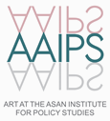 | 8 pages | Contact: Embassy of the Czech Republic,  Eunmin Lim (Curator of the AAIPS Gallery)
 | Tel.: 02) 3701-7340  www.aaips-gallery.com | E-mail: seoul@embassy.mzv.cz  elim@asaninst.org

"1989 Velvet Revolution – The Fall of the Iron Curtain” at the AAIPS Gallery
A Photography Exhibition Organized by the Visegrád Group
To Commemorate the 30th Anniversary of the Fall of the Communist Regime

■ The embassies of the four Visegrád countries – the Embassies of the Czech Republic, Slovakia, Poland and Hungary in Seoul – have organized a photography exhibition entitled "1989 Velvet Revolution – The Fall of the Iron Curtain” to commemorate the 30th anniversary of the fall of the communist regime. The exhibition will be held at the AAIPS Gallery of the Asan Institute for Policy Studies at Jongno-gu, Seoul, from November 16th until December 1st, 2019.
■ With the Czech presidency of the Visegrád Group in 2019/2020, the Embassy of the Czech Republic in Seoul invited the Embassies of the group's three other countries to cooperate in this exhibition, as the Czechoslovak Velvet Revolution is closely intertwined with the revolutions and events of the other nations of former communist bloc.
■ This exhibition brings a selection from a larger exhibition currently being held at the Prague Castle. A Castle spokesperson comments, "It is a selection of truly unique moments that often do not need any further words or explanations. The photographs accurately reflect the unique atmosphere, enthusiasm, hope, determination, and desire for freedom of that time. Outside and inside, there are screens showing the most important events.”
■ The viewers can see the best of Czech, Slovak, Hungarian, Polish, Bulgarian, Romanian and German photographers. Their work offers an extensive photographic testimony to the turnaround year of 1989 in Central Europe, marking the end of a barrier that had divided the world for more than four decades. The event will evoke memories in those who lived through those times and witnessed those exciting moments. It will also bring younger generations closer to the dramatic events, more so than history books can ever do.
■ Gustav Slamečka, Ambassador of the Czech Republic to the Republic of Korea, said, “These photographs record the events that happened 30 years ago in countries geographically distant from South Korea. With those events, the Cold War disappeared into history, but here, on the Korean Peninsula, it is still ongoing in the form of the division of Korea. This is why it is all the more significant that this exhibition is being held in Seoul. We hope that this exhibition will inspire Korean people to dream about the fall of the iron curtain and overcome division in the future.”
■ This exhibition was created in cooperation with the Office of the President of the Czech Republic as well as the Prague Castle Administration, and is held under the auspices of Miloš Zeman, the President of the Czech Republic.
■ The AAIPS Gallery of the Asan Institute for Policy Studies is hosting this exhibition as a part of its program to broaden the base of public diplomacy through a collaboration with the diplomatic community in Korea, with the aim to introduce a variety of different cultures to Koreans.
* [Reference] About the Photography Exhibition, “1989 Velvet Revolution – The Fall of the Iron Curtain”

Reference

About the Photography Exhibition
"1989 Velvet Revolution – The Fall of the Iron Curtain”

1. Exhibition Description
■ Organizers: The Embassies of the four Visegrád countries to the Republic of Korea
(The Embassies of the Czech Republic, Slovakia, Poland and Hungary)
The Office of the President of the Czech Republic
The Prague Castle Administration
The AAIPS Gallery of the Asan Institute for Policy Studies
■ Title: "1989 Velvet Revolution – The Fall of the Iron Curtain”
■ Works: 71 photographs
■ Artists: 26 photographers, including Chris Niedenthal
■ Dates: 16 November – 01 December 2019
■ Opening Hours: 10 am. – 5 pm. (Last day 10 am. – 12 noon)
■ Venue: AAIPS Gallery, The Asan Institute for Policy Studies
(11 Gyeunghuigung 1 ga-gil, Jongno-gu, Seoul)
■ Opening Reception: 15 November 2019, 3 pm. / AAIPS Gallery
■ Exhibition-related Event: Screening of the Czechoslovak film, “The Ear”
15 November 2019, 4.15 pm.
Auditorium of the Asan Institute for Policy Studies

2. Exhibition Overview

The Fall of the Iron Curtain

There are few symbolic moments in the history of the 20th century as the fall of the Berlin Wall on November 9th 1989. In a symbolic way, the fall may have also been the end of the 20th century, certainly the world of the Cold War and its clearly-defined power blocs.

Winston Churchill, in 1946, characterized the results of the Second World War as the descent of an Iron Curtain over Europe: “From the Stein in the Baltic to Trieste in the Adriatic, an iron curtain has descended across the Continent. Behind this line lie all the capital cities of the ancient states of Central and Eastern Europe: Warsaw, Berlin, Prague, Vienna, Budapest, Belgrade, Bucharest and Sofia, all these famous cities and the populations around them lie in what I must call the Soviet sphere.“ This was the reality to him - the Hungarian Revolution of 1956 or the Prague Spring of 1968 did not change the strength of this curtain. The Soviet sphere of influence stood firm.

Moreover, it was not just an ideological sphere, but the Iron Curtain was then launched physically, building a border belt with wire systems all along it and in 1961, in Berlin, by building a solid wall. Only the international situation in the second half of the 1980s changed everything. In particular, the inauguration of Mikhail S. Gorbachev as the leader of the Soviet Union, which brought about changes in the politics of this super-power towards its (up until now) fiefdoms. And, the Eastern European countries used these changes in 1989. In Poland, partial elections were even held, in which the opposition party, Solidarity, was overwhelmingly victorious. Forcible dissent in many other countries played an increasingly important role. The Hungarians were the first to open closed borders, followed by the nervous movement of exiles from Eastern Germany to Central European countries, and eventually the borders of Czechoslovakia opened.

The situation in Central Europe has always been, to a large extent, dependent on the international set-up. Therefore, not only the November fall of the Berlin Wall, but also the meeting of Mikhail Gorbachev and George Bush in Malta on December 2nd and 3rd 1989 were crucial. The result of this meeting was a statement by both leaders of these world powers that the period of the Cold War and the dependence of Central and Eastern Europe on particular powers were at an end. “We are leaving one epoch, the Cold War, and entering a new era,“ Gorbachev said. “The United States and the Soviet Union are entering a new era of mutual relations,“ said Bush.

3. Major Works

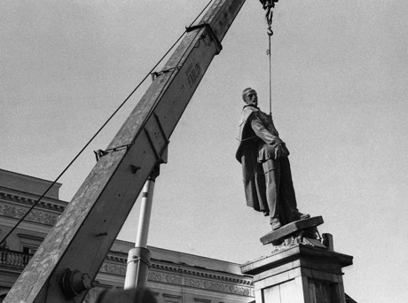
Aleksander Jalosinski. The destruction of the memorial to Felix Dzerzhinsky, the founder of the Soviet secret police and of Polish origin, became a symbol of the end of communism in Poland. Warsaw, November 1989.

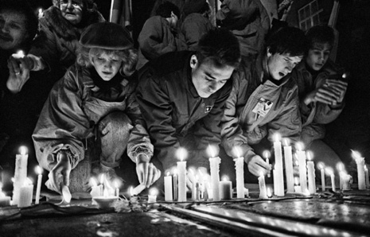
Jaroslav Kučera. Piety a month after the brutal police intervention against students. Prague, Národní třída, December 17th, 1989.

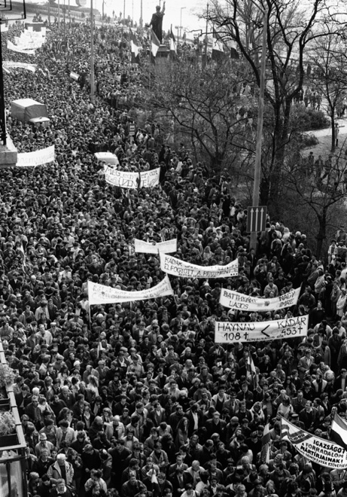
András Bankuti. Demonstration on the occasion of the Hungarian national holiday on March 15th, which commemorates the revolution and the war of independence in 1848. Budapest, March 15th, 1989.

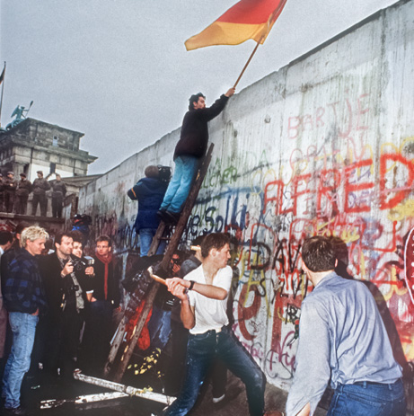
Andrej Reiser. The concrete panels could not resist human strength. Berlin, November 10th, 1989.

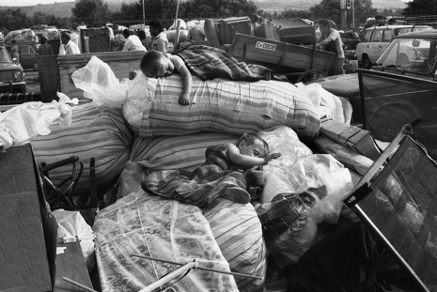
Ivan Grigorov. The family property of the Bulgarian Turks on their wagons, with sleeping kids,
in a long line at the Bulgarian-Turkish border. Kapitan Andrejevo, August 1989.

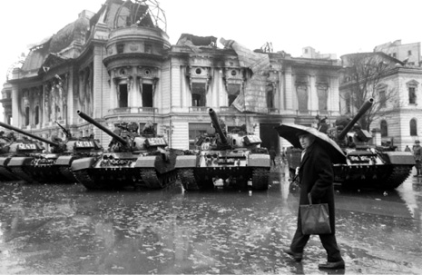
András Bankuti. Bucharest rose up and tanks came onto the streets. In the fierce fighting,
the army finally stood on the side of the rebels, while the security police units (the Securitate)
supported the dictator Ceauşescu. December 1989.

